**Practical No. 8**

**Write a PHP program to –**

1. **Inherit members of super class in subclass.**

**Code (Pgno. 8):**

<?php

class Car

{

}

$Maruti=new Car();

$Honda=new Car();

print_r($Maruti);

print_r($Honda);

?>

**Output:**

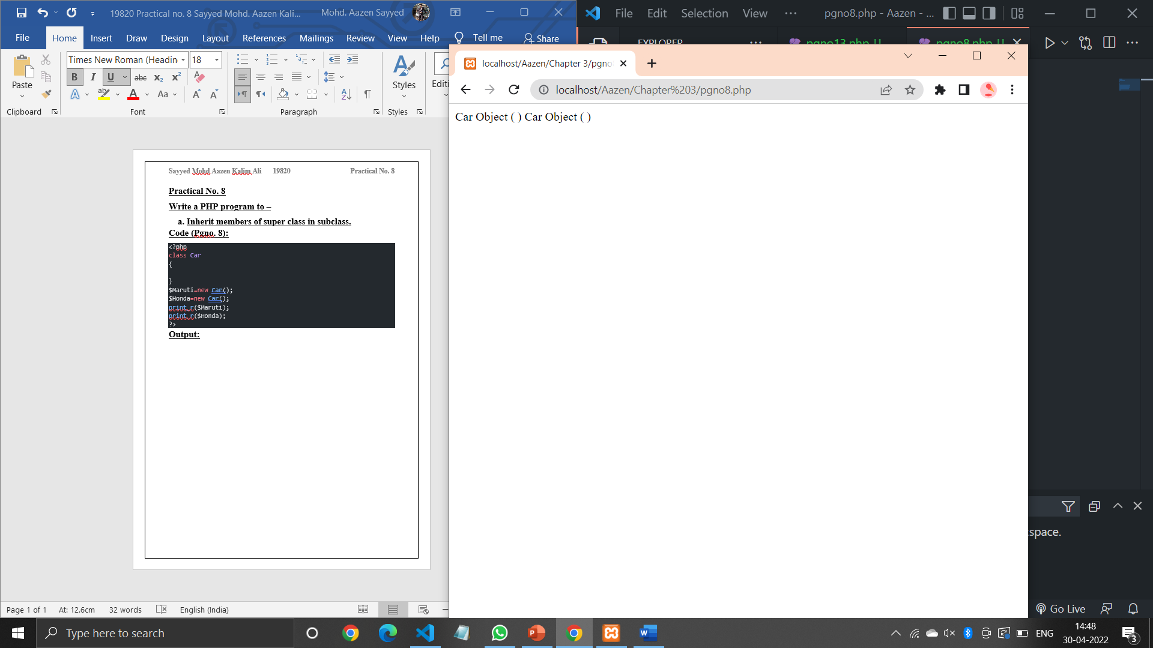

**Code (Pgno. 13):**

<?php

class student{

 public $name;

 public $city;

 function set_name($name){

 $this->name = $name;

 }

 function get_name() {

 return $this->name;

 }

}

$stu1 = new student();

$stu2 = new student();

$stu1->set_name('Aazen');

$stu2->set_name('Siddhesh');

echo $stu1->get_name();

echo "<br>";

echo $stu2->get_name();

?>

**Output:**

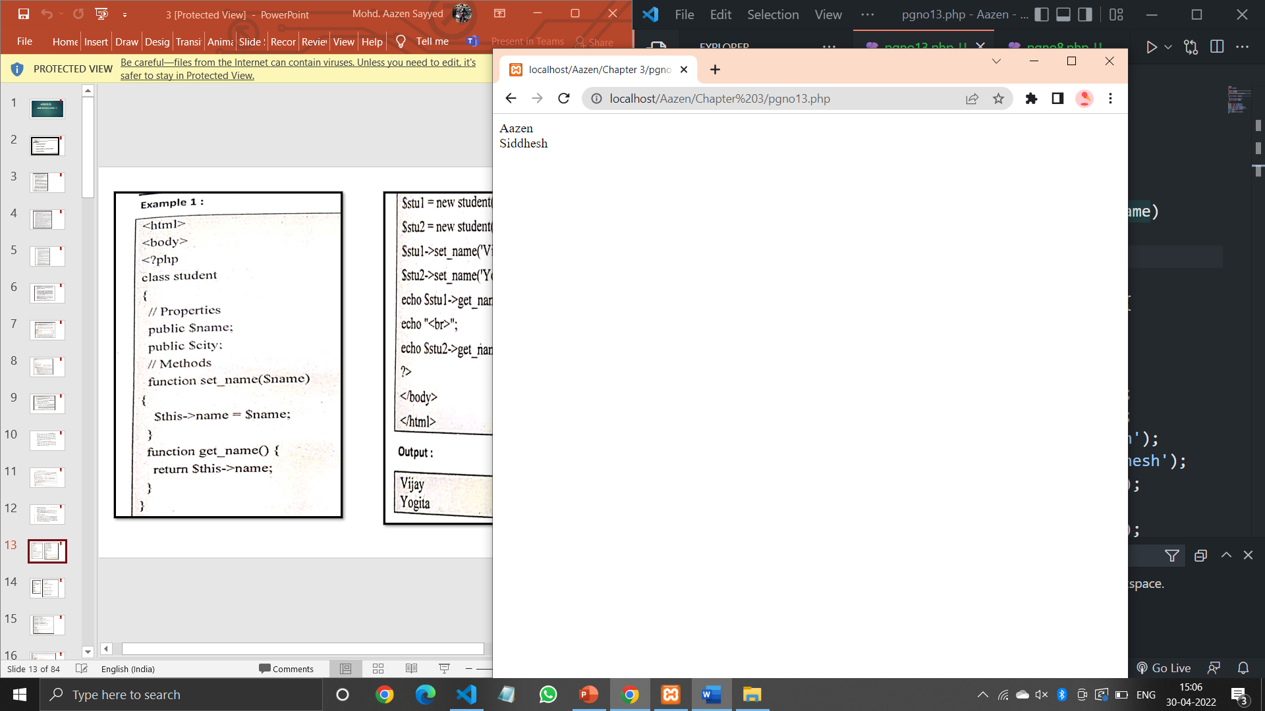

**Code (Pgno. 14):**

<?php

class Fruit

{

    public $name;

    public $col;

    function set_name($name)

    {

        $this->name=$name;

    }

    function get_name()

    {

        return $this->name;

    }

    function set_color($color)

    {

        $this->col=$color;

    }

    function get_color()

    {

        return $this->col;

    }

}

    $apple = new Fruit();

    $apple->set_name('Apple');

    $apple->set_color('Red');

    echo "Name: ".$apple->get_name();

    echo "<br>";

    echo "Color: ".$apple->get_color();

    echo "<br>";

    $pineapple = new Fruit();

    $pineapple->set_name('Pine-Apple');

    $pineapple->set_color('Yellow');

    echo "Name: ".$pineapple->get_name();

    echo "<br>";

    echo "Color: ".$pineapple->get_color();

    echo "<br>";

    $orange = new Fruit();

    $orange->set_name('Orange');

    $orange->set_color('Orange');

    echo "Name: ".$orange->get_name();

    echo "<br>";

    echo "Color: ".$orange->get_color();

?>

**Output:**

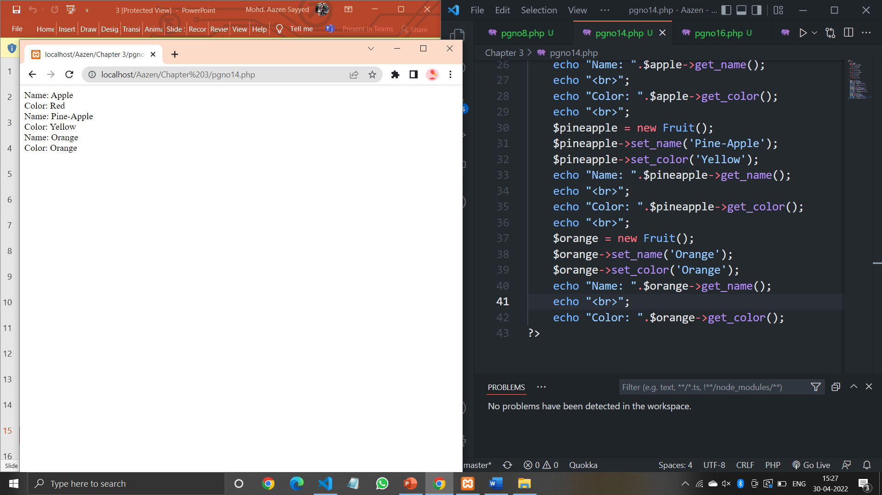

**Code (Pgno. 16):**

<?php

class Rectangle

{

 // Declare properties

 public $length = 0;

 public $width = 0;

 // Method to get the perimeter

 public function getPerimeter()

{

 return (2 * ($this->length + $this->width));

 }

 // Method to get the area

public function getArea()

{

 return ($this->length * $this->width);

 }

}

// Create a new object from Rectangle class

$obj = new Rectangle;

// Get the object properties values

echo $obj->length . "<br>"; // 0utput: 0

echo $obj->width . "<br>"; // 0utput: 0

// Set object properties values

$obj->length = 30;

$obj->width = 20;

// Read the object properties values again to show the change

echo "Length:" . $obj->length . "<br>"; // 0utput: 30

echo "Width:" . $obj->width . "<br>"; // 0utput: 20

// Call the object methods

echo "Perimeter:" . $obj->getPerimeter() . "<br>"; // 0utput: 100

echo "Area:" . $obj->getArea() . "<br>"; // Output: 600

**Output:**

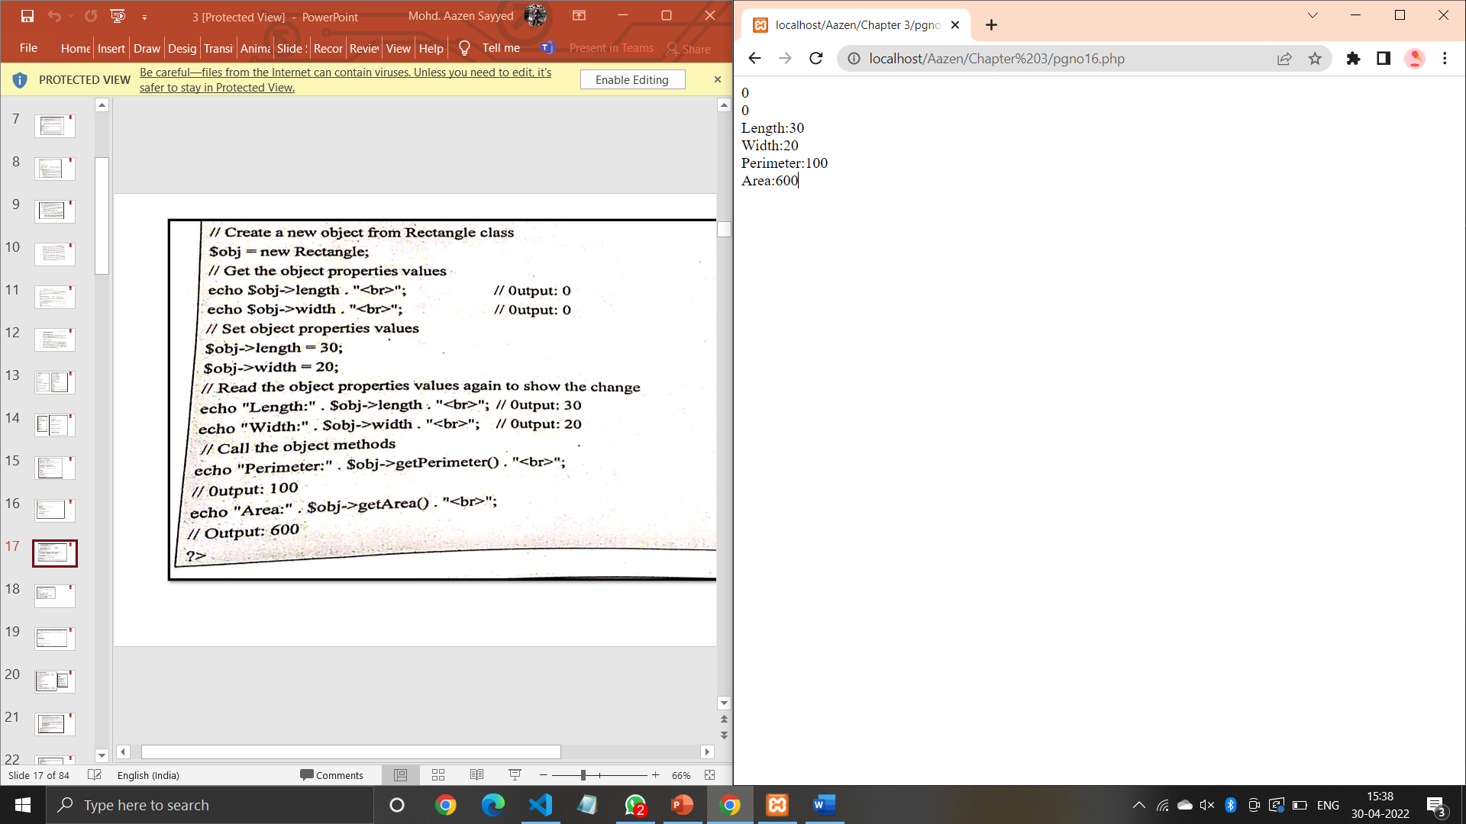

**Code (Pgno. 19):**

<?php

class Rectangle

{

 public $length = 0;

 public $width = 0;

 public function getArea()

{

 return ($this->length * $this->width);

}

}

$obj1 = new Rectangle;

$obj2 = new Rectangle;

echo "Area of object1:".$obj1->getArea()."<br>";

echo "Area of object2:".$obj2->getArea()."<br>";

$obj1->length = 30;

$obj1->width = 20;

$obj2->length = 35;

$obj2->width = 50;

echo "After calling<br>";

echo "Area of object 1: ".$obj1->getArea()."<br>";

echo "Area of object 2: ".$obj2->getArea()."<br>";

?>

**Output:**

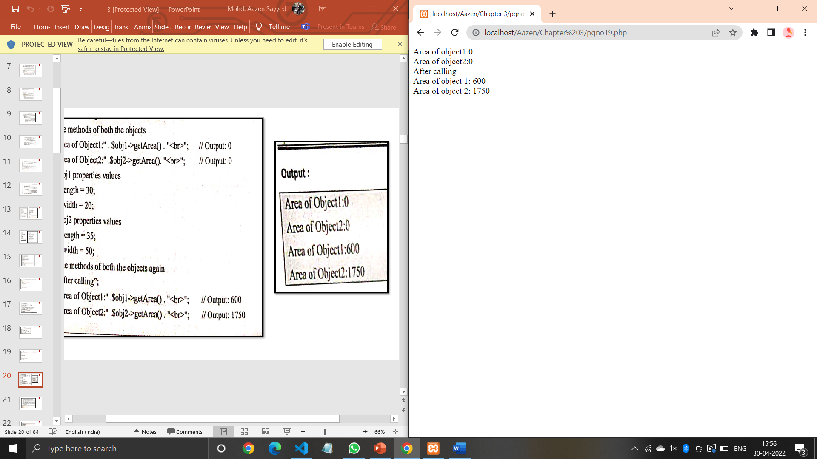

**Code (Pgno. 22):**

<?php

class demo{

    var $first=10;

    var $second=20;

    function add()

    {

        $add=$this->first + $this->second;

        echo "Addition= ".$add."<br>";

    }

    function sub()

    {

        $sub=$this->first - $this->second;

        echo "Subtraction= ".$sub."<br>";

    }

    function mul()

    {

        $mul=$this->first * $this->second;

        echo "Multiplication= ".$mul."<br>";

    }

    function summary()

    {

        $this->add();

        $this->sub();

        $this->mul();

        $res=$this->first * $this->second;

        echo "Multiplication= ".$res;

    }

}

$obj=new demo();

$obj->summary();

?>

**Output:**

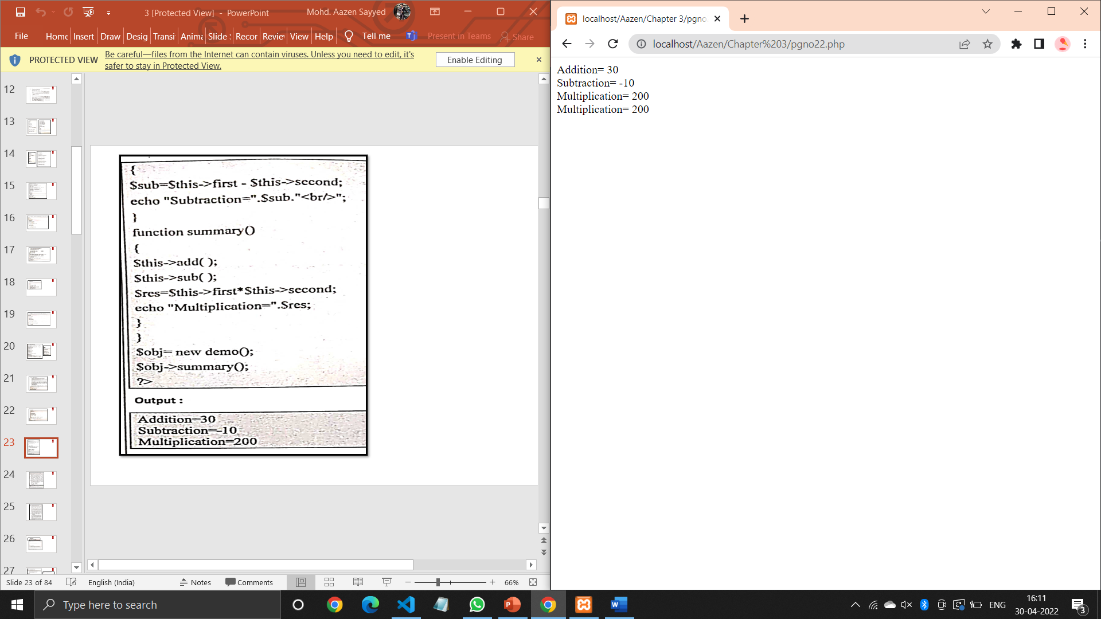

**Code (Pgno. 26):**

<?php

class MyClass

{

function __construct()

{

    echo "Welcome to PHP constructor.<br>";

}

}

$obj=new MyClass;

?>

**Output:**

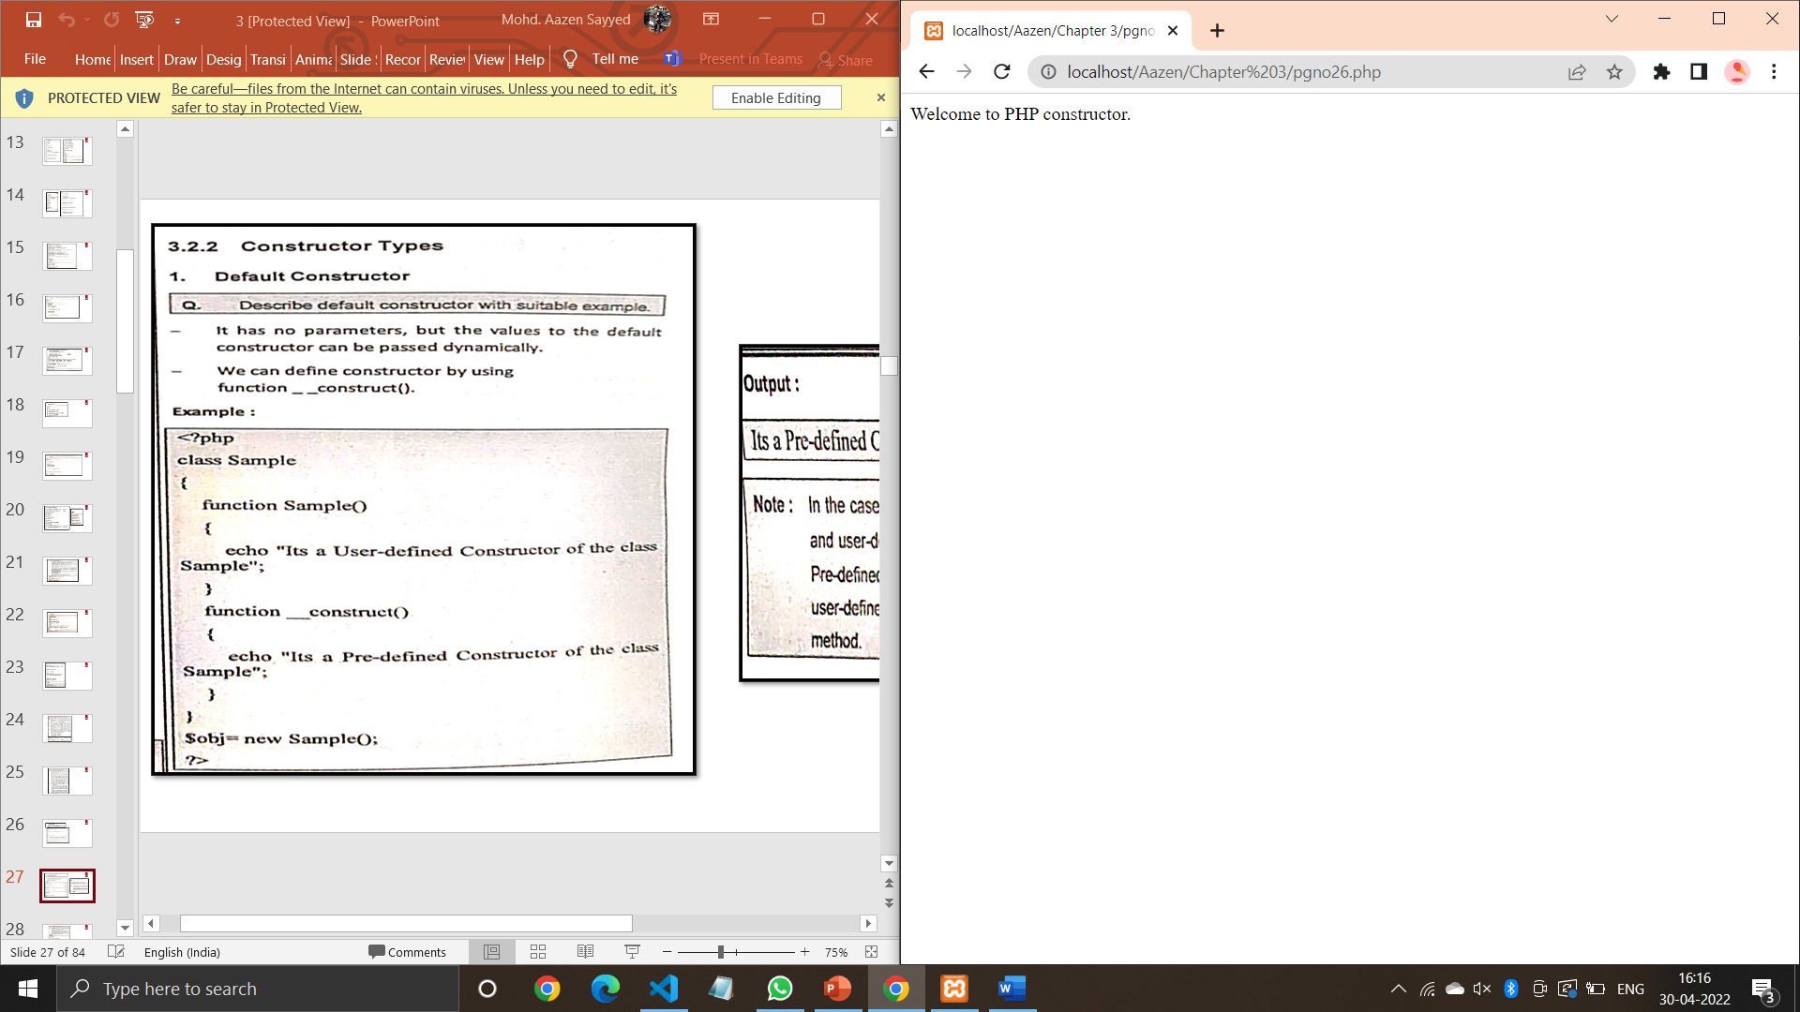

**Code (Pgno. 27):**

<?php

class Sample

{

    function Sample()

    {

        echo "Its a user-defined Constructor of the class Sample";

    }

    function __construct()

    {

        echo "Its a pre-defined Constructor of the class Sample";

    }

}

$obj= new Sample();

?>

**Output:**

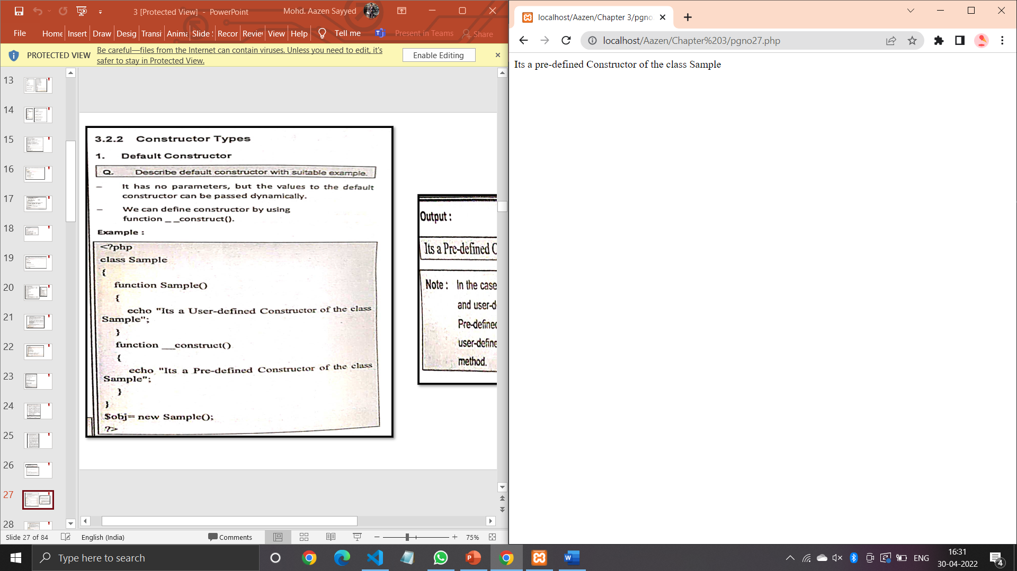

**Code (Pgno. 28):**

<?php

class emp{

    private $fname;

    private $lname;

    public function __construct($fname,$lname)

    {

        echo "Initialising the object...<br>";

        $this->fname=$fname;

        $this->lname=$lname;

    }

    public function showName()

    {

        echo "My name is : Mr. ".$this->fname." ".$this->lname;

    }

}

$sid=new emp("Aazen","Sayyed");

$sid->showName();

?>

**Output:**

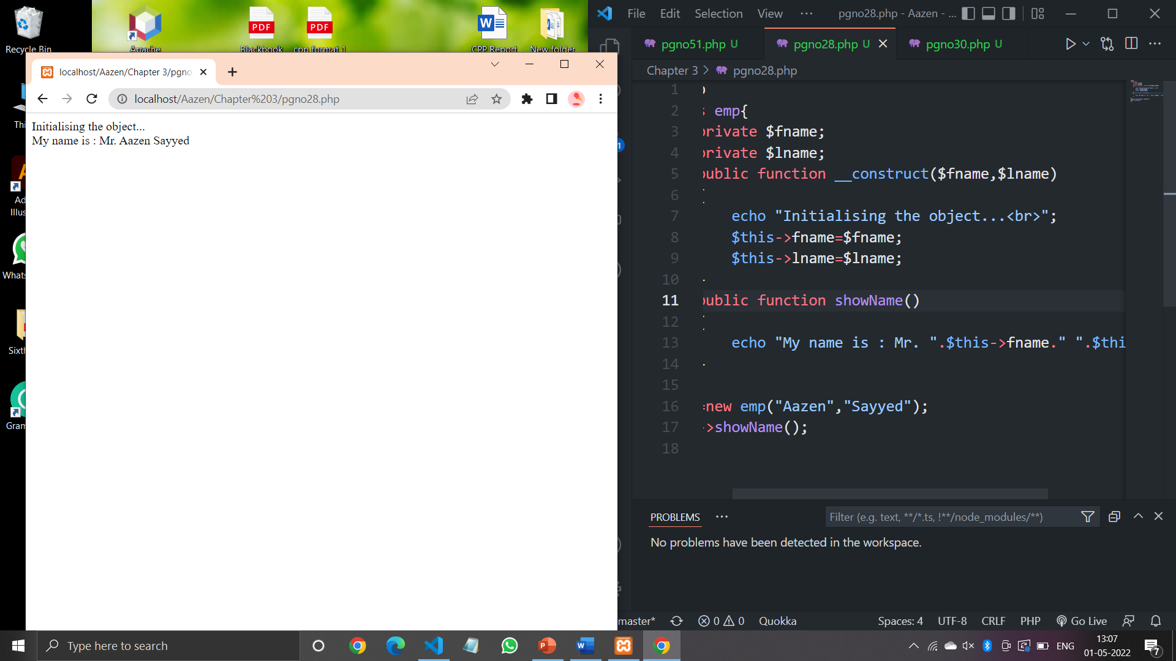

**Code (Pgno. 30):**

<?php

class Employee

{

    public $name;

    public $profile;

    function __construct($name,$position)

    {

        $this->name=$name;

        $this->profile=$position;

    }

    function show_details()

    {

        echo $this->name." : ";

        echo "Your position is ". $this->profile."<br>";

    }

}

$employee_obj=new Employee("Aazen Sayyed","Developer");

$employee_obj->show_details();

$employee2=new Employee("Vijay Patil","Manager");

$employee2->show_details();

?>

**Output:**

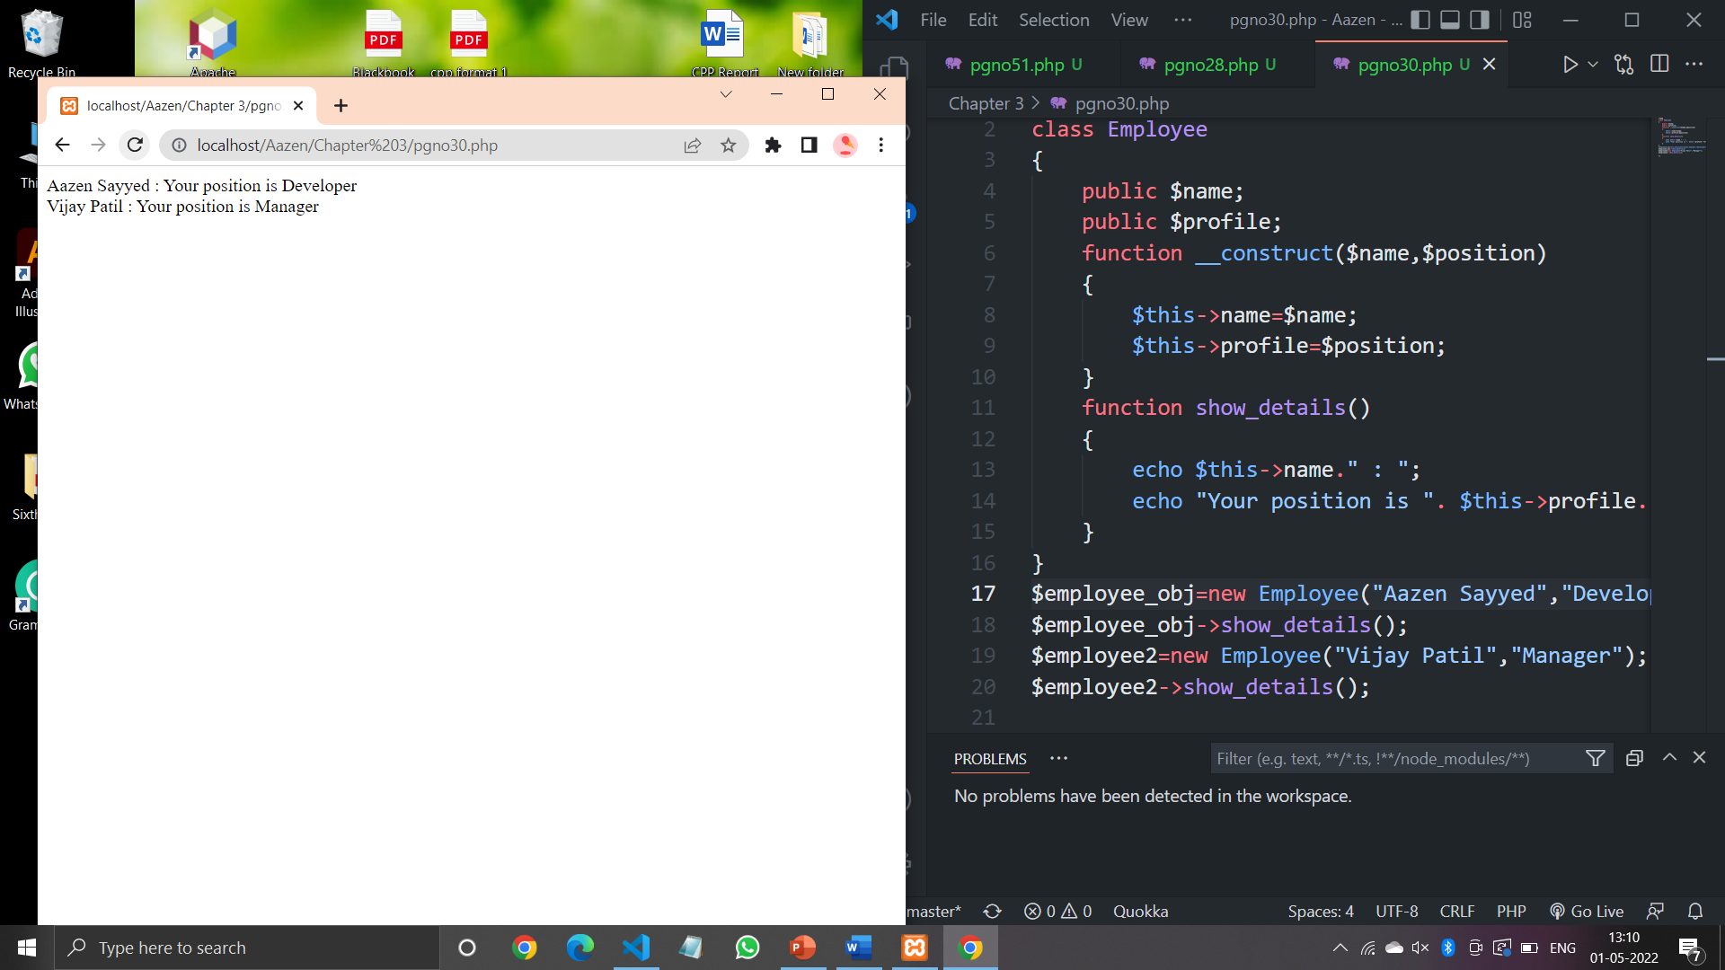

**Code (Pgno. 33):**

<?php

class MyDestClass

{

    function __construct()

    {

        print "In Constructor<br>";

    }

    function __destruct()

    {

        print "Destroying ".__CLASS__."<br>";

    }

}

$obj=new MyDestClass();

?>

**Output:**

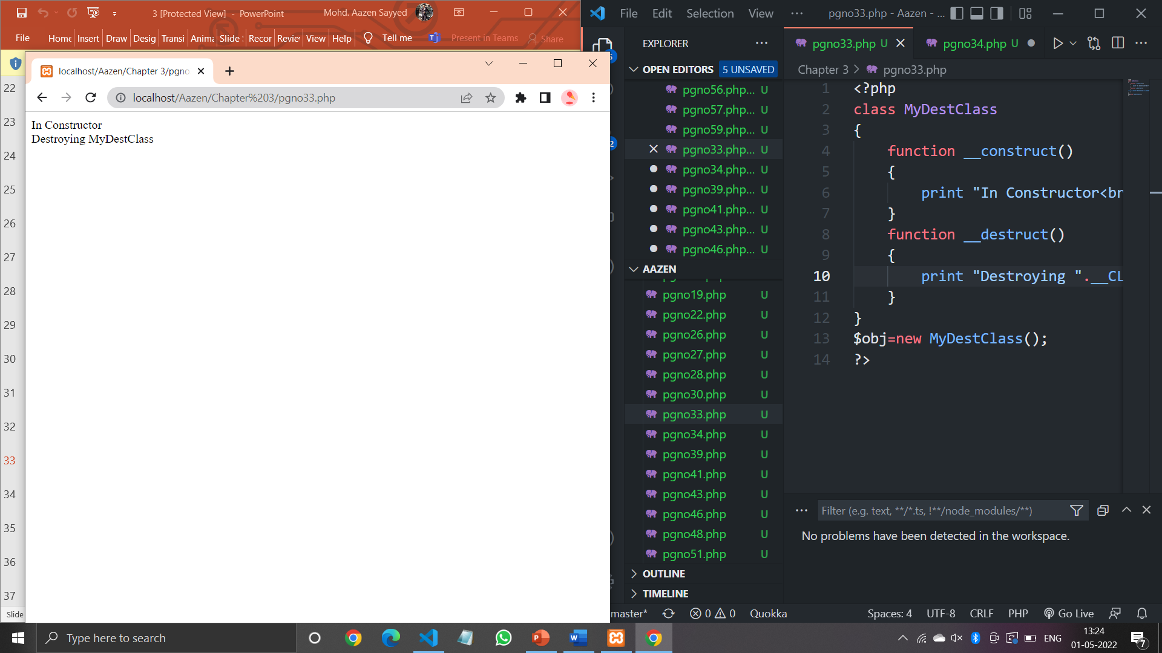

**Code (Pgno. 34):**

<?php

class Person

{

    private $fname;

    private $lname;

    public function __construct($fname,$lname)

    {

        echo "Initialising the object...<br>";

    $this->fname=$fname;

    $this->lname=$lname;

    }

    public function __destruct()

    {

        echo "Destructing Object...";

    }

    public function showName()

    {

      echo "My name is: Mr. ". $this->fname." ". $this-> lname."<br>";

    }

}

$sid=new Person("Aazen","Sayyed");

$sid->showName();

?>

**Output:**

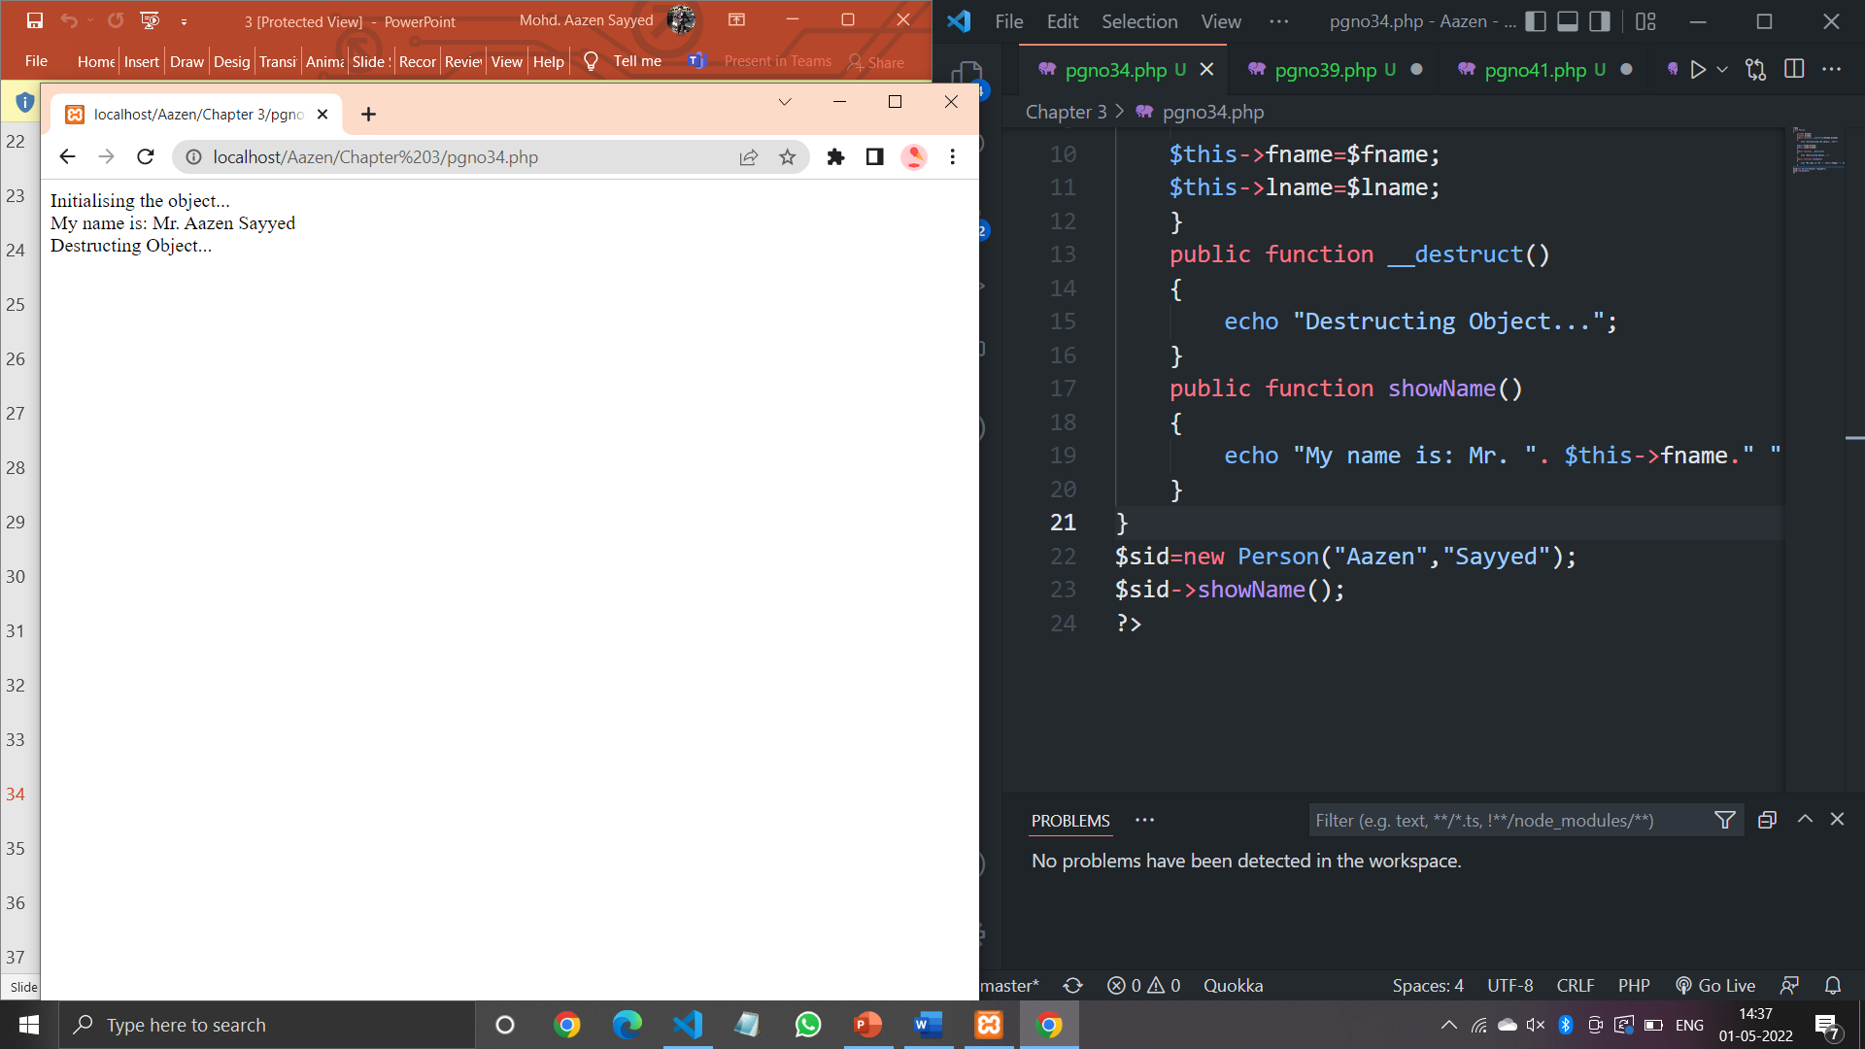

**Code (Pgno. 39):**

<?php

class Shape {

    public $length;

    public $width;

    public function __construct($length,$width)

    {

        $this->length=$length;

        $this->width=$width;

    }

}

class Rect extends Shape{

    public $height;

    public function __construct($length,$width,$height)

    {

        $this->length=$length;

        $this->width=$width;

        $this->height=$height;

    }

    public function intro()

    {

        echo "The length is {$this->length}, the width is {$this->width}, and height is {$this->height}.";

    }

}

$r=new Rect(10,20,30);

$r->intro();

?>

**Output:**

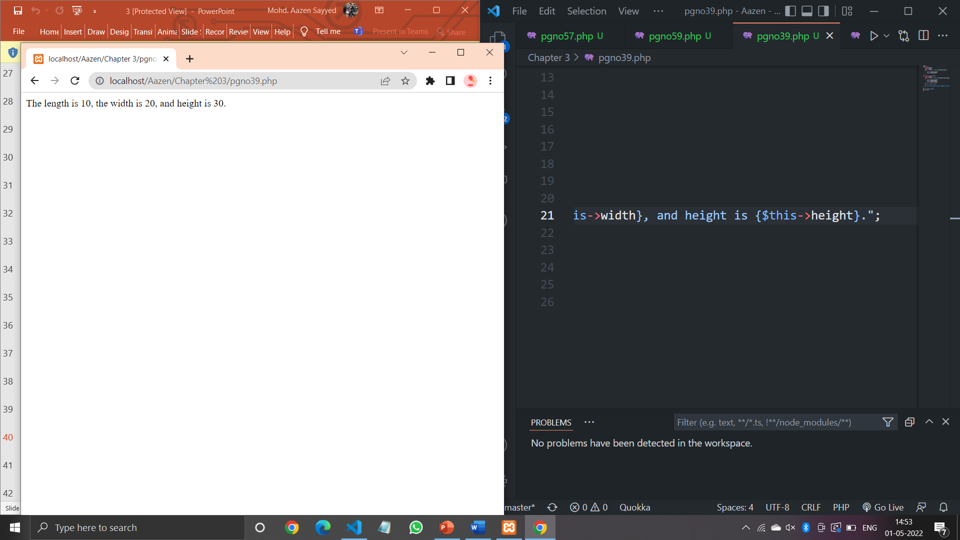

**Code (Pgno. 41):**

<?php

class Shape

{

    public $length;

    public $width;

    public function __construct($length,$width)

    {

        $this->length=$length;

        $this->width=$width;

    }

    public function intro()

    {

        echo "The length is {$this->length} and the width is {$this->width}.";

    }

}

class Rect extends Shape

{

    public $height;

    public function __construct($length,$width,$height)

    {

    $this->length=$length;

    $this->width=$width;

    $this->height=$height;

    }

    protected function introduction()

    {

       echo "The length is{$this->length}, the width is {$this->width},and the height is {$this->height}";

    }

}

$r=new Rect(10,20,30);

$r->intro();

$r->introduction();

?>

**Output:**

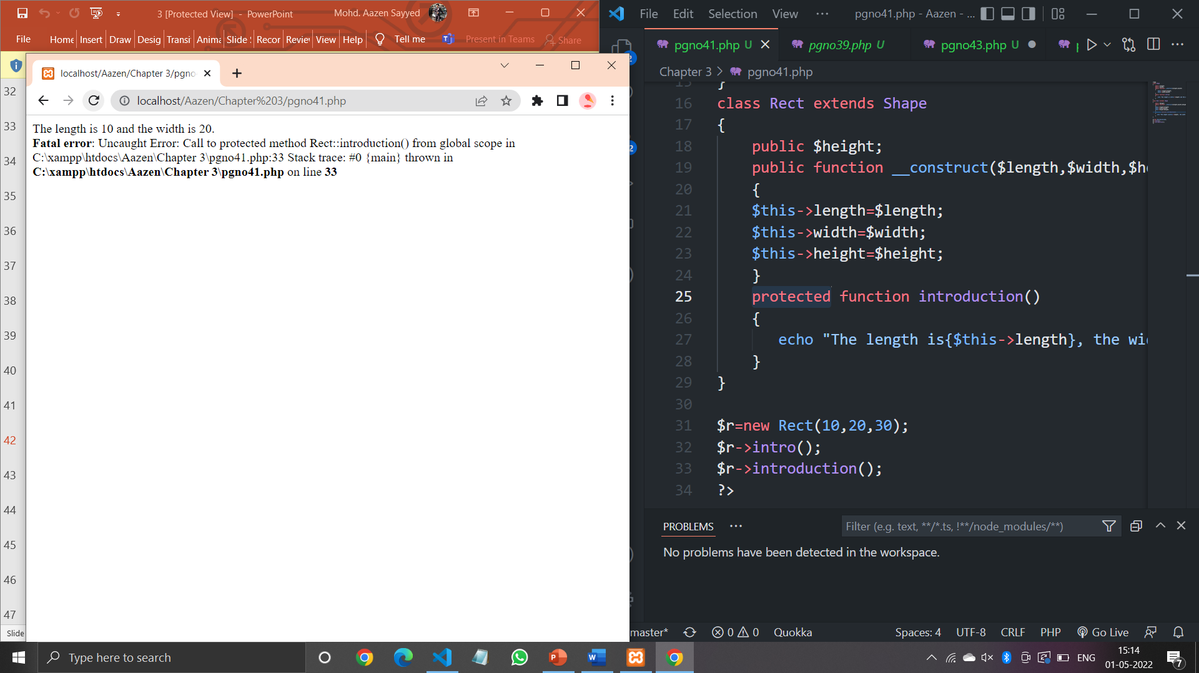

**Code (Pgno. 43):**

<?php

class Shape{

    public $length;

    public $width;

    public function __construct($length,$width)

    {

        $this->length=$length;

        $this->width=$width;

    }

    protected function intro()

    {

        echo "The length is {$this->length} and the width is {$this->width}.";

    }

}

class Rect extends Shape

{

    public function introduction()

    {

        echo "The shape is rectangle.";

        $this->intro();

    }

}

$r=new Rect(10,20);

$r->introduction();

?>

**Output:**

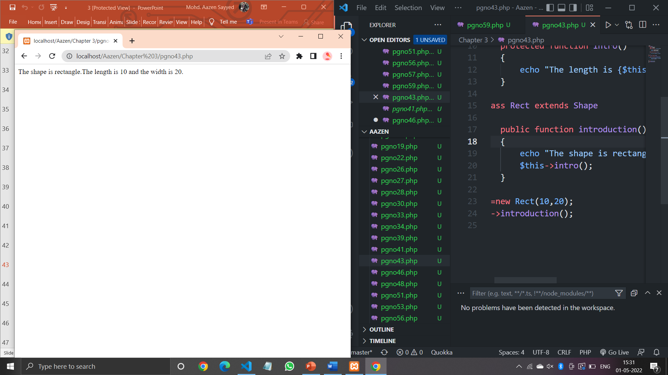

**Code (Pgno. 46):**

<?php

class a

{

    function dis1()

    {

        echo "Hello PHP<br>";

    }

}

class b extends a

{

    function dis2()

    {

        echo "PHP Programming<br>";

    }

}

$obj=new b();

$obj->dis1();

$obj->dis2();

?>

**Output:**

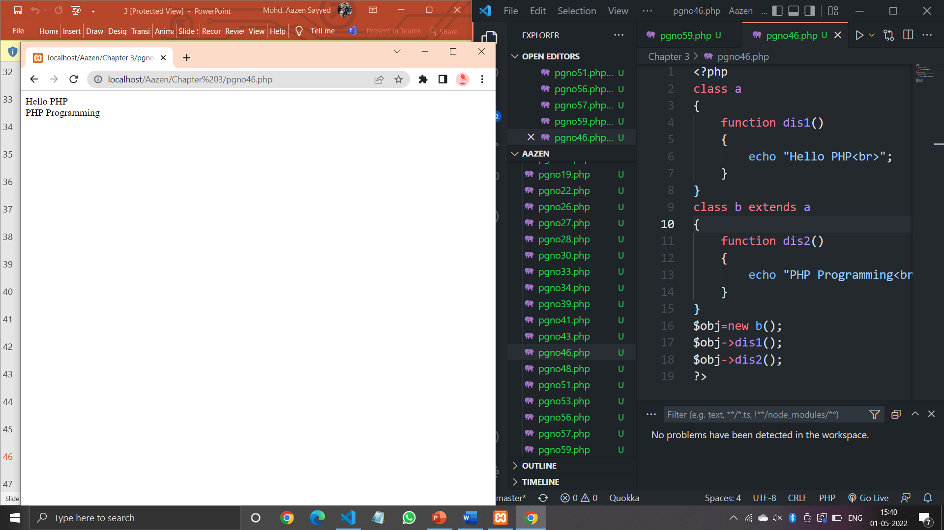

**Code (Pgno. 48):**

<?php

class grandparent

{

    function dis1()

    {

        echo "Grand-Parents<br>";

    }

}

class parents extends grandparent

{

    function dis2()

    {

        echo "Parents<br>";

    }

}

class child extends parents

{

    function dis3()

    {

        echo "Child<br>";

    }

}

$obj=new child();

$obj->dis1();

$obj->dis2();

$obj->dis3();

?>

**Output:**

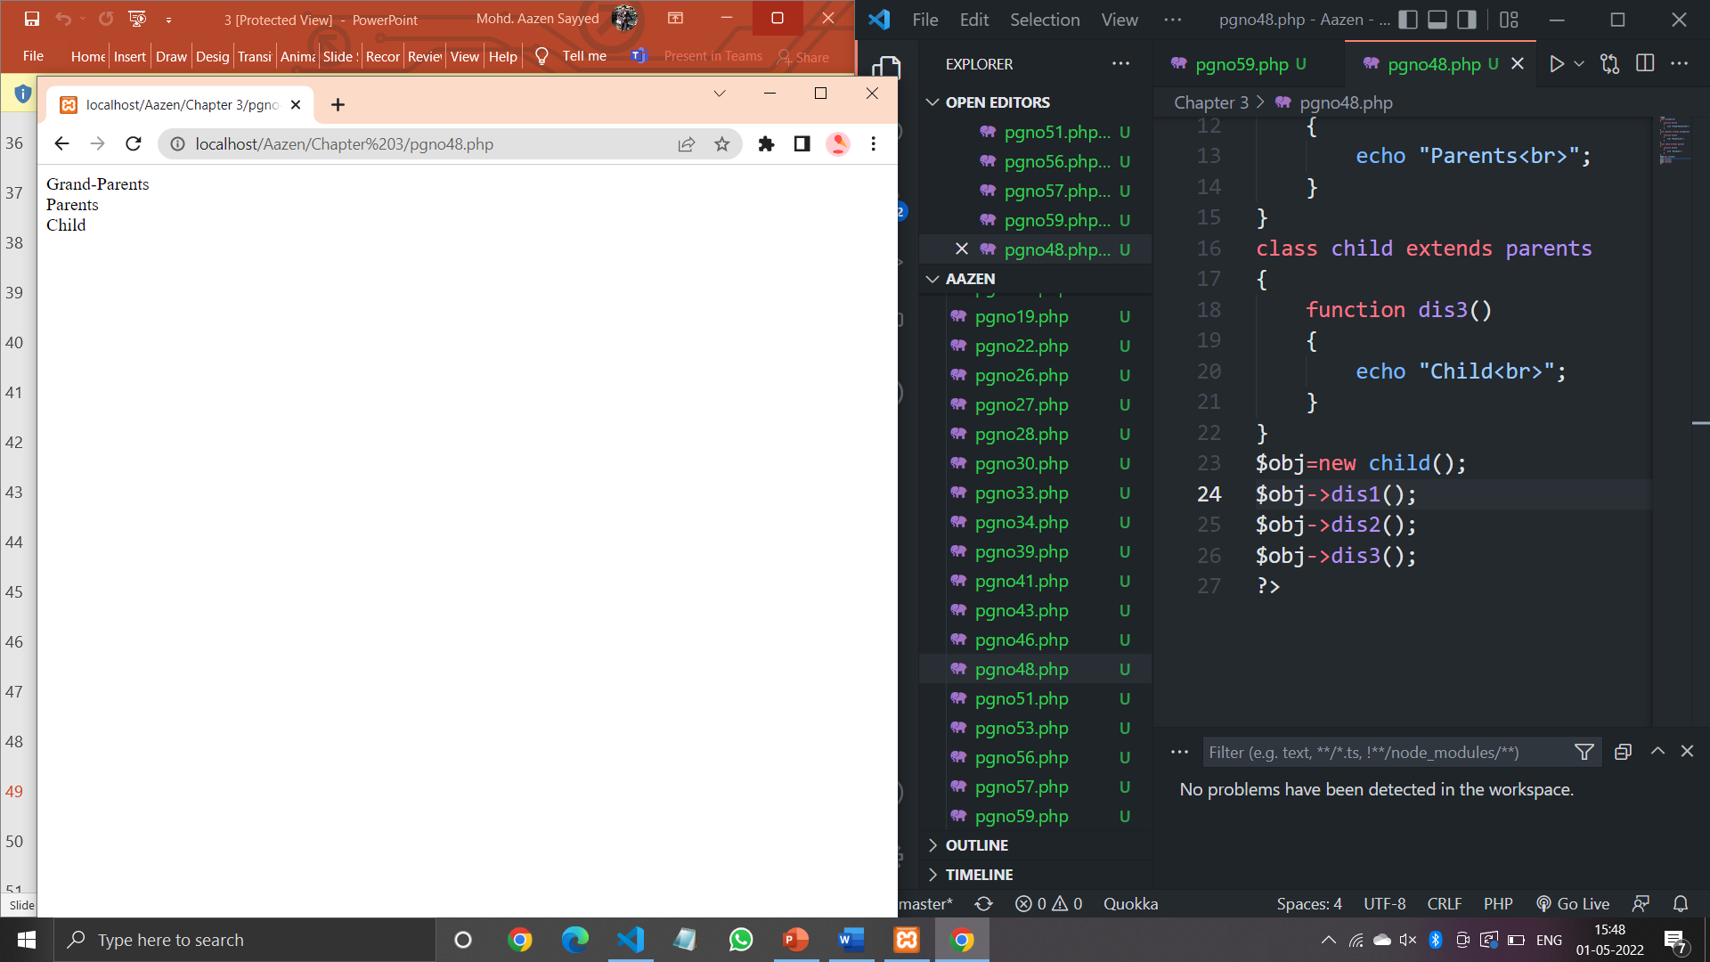

**Code (Pgno. 51):**

<?php

class a

{

    function function_a()

    {

    echo "class A<br>";

    }

}

class b extends a

{

    function function_b()

    {

    echo "class B<br>";

    }

}

class c extends a

{

    function function_c()

    {

    echo "class C<br>";

    }

}

$obj=new c();

$obj->function_c();

$obj->function_a();

?>

**Output:**

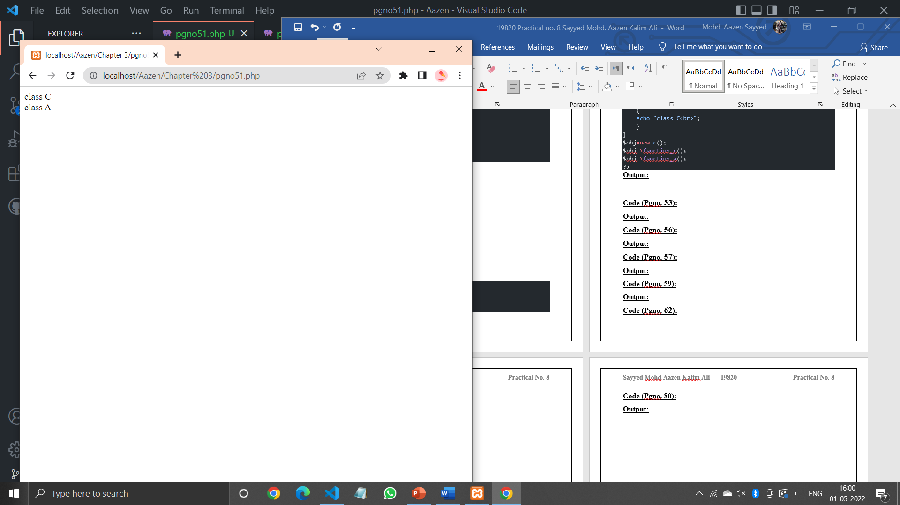

**Code (Pgno. 53):**

<?php

class A{

    public function dis1()

    {

        echo "Parent-A<br>";

    }

}

trait B

{

    public function dis2()

    {

        echo "Parent-B<br>";

    }

}

class C extends A

{

    use B;

    public function dis3()

    {

        echo "Child-C";

    }

}

$obj=new C();

$obj->dis1();

$obj->dis2();

$obj->dis3();

?>

**Output:**

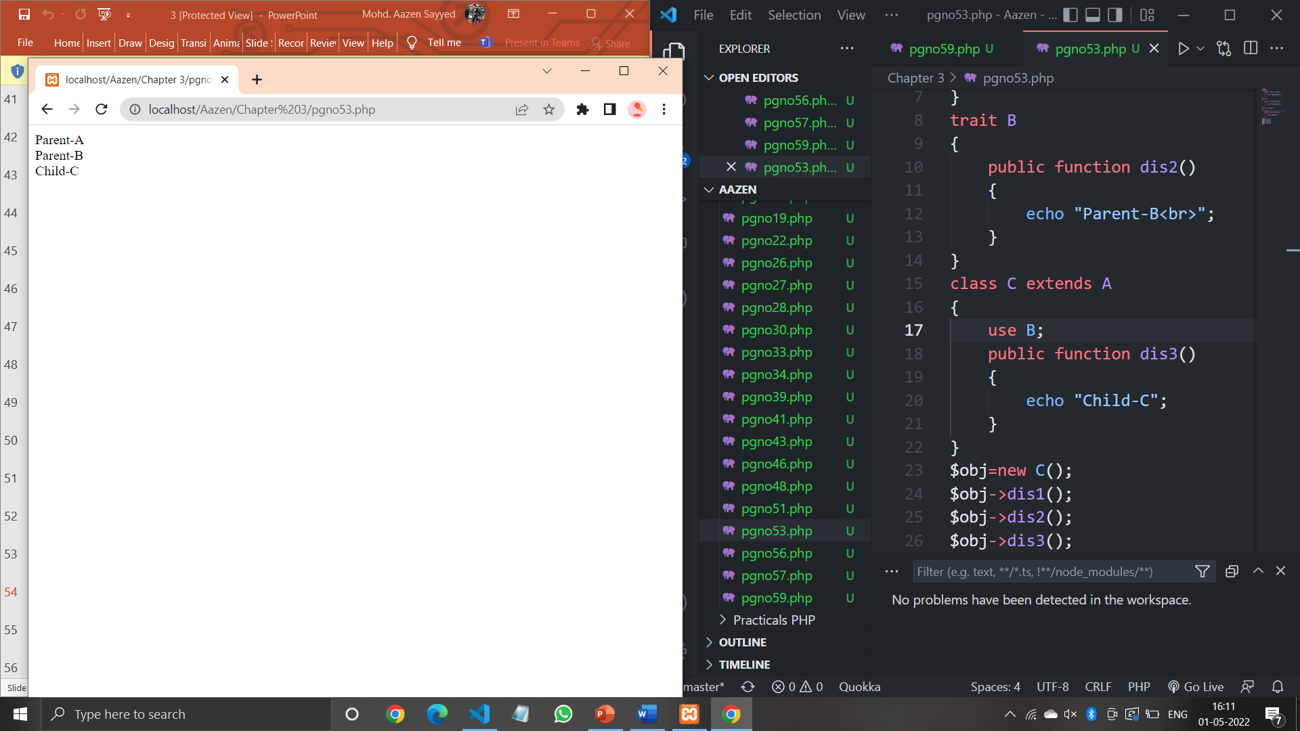

**Code (Pgno. 56):**

<?php

class A

{

    public function dis1()

    {

        echo "Parent-A<br>";

    }

}

interface B

{

    public function dis2();

}

class C extends A implements B

{

    function dis2()

    {

        echo "Parent-B<br>";

    }

    public function dis3()

    {

        echo "Child-C<br>";

    }

}

$obj=new C();

$obj->dis1();

$obj->dis2();

$obj->dis3();

?>

**Output:**

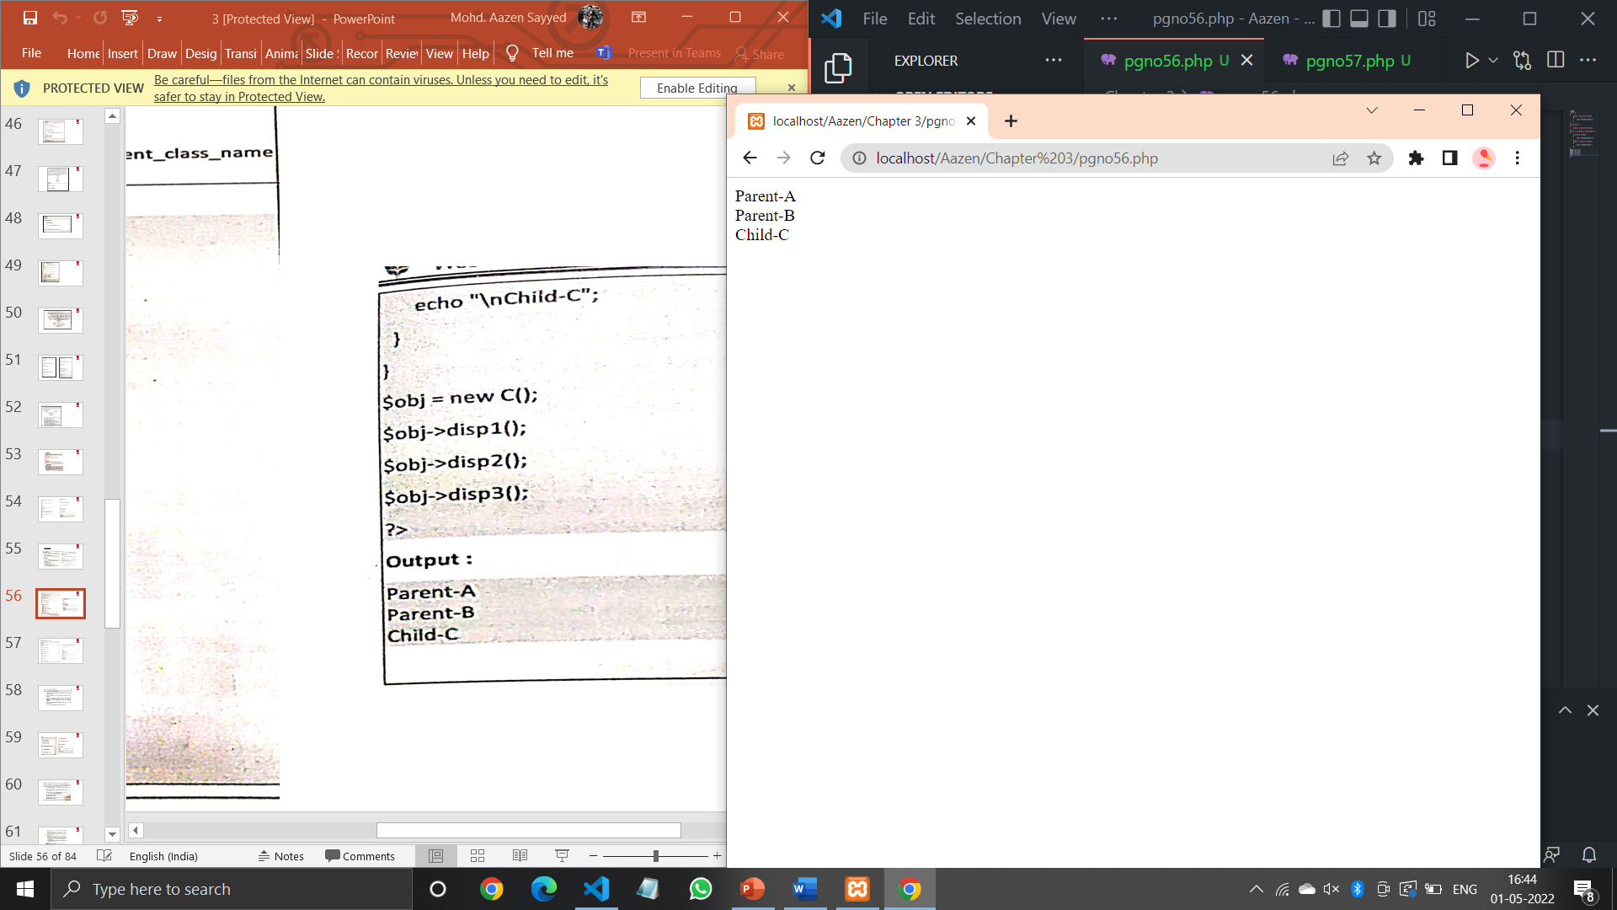

**Code (Pgno. 57):**

<?php

interface A{

    public function dis1();

}

interface B{

    public function dis2();

}

class C implements A,B{

    function dis1(){

        echo "Parent-A<br>";

    }

    function dis2(){

        echo "Parent-B<br>";

    }

    public function dis3(){

        echo "Child-C";

    }

}

$obj=new C();

$obj->dis1();

$obj->dis2();

$obj->dis3()

?>

**Output:**

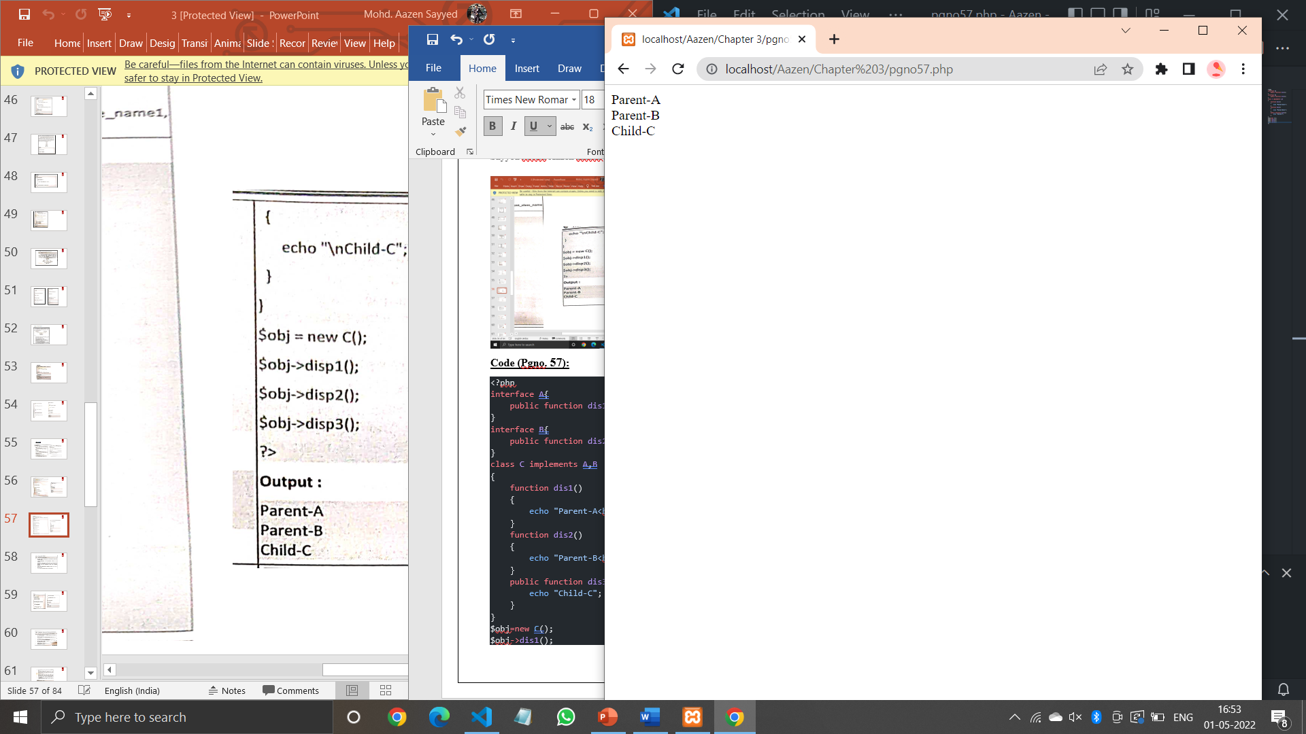

**Code (Pgno. 59):**

<?php

interface InterfaceName{

    public function method1();

    public function method2();

}

class ClassName implements InterfaceName

{

    public function method1()

    {

        echo "Method1 Called". "<br>";

    }

    public function method2()

    {

        echo "Method2 Called". "<br>";

    }

}

$obj=new ClassName;

$obj->method1();

$obj->method2();

?>

**Output:**

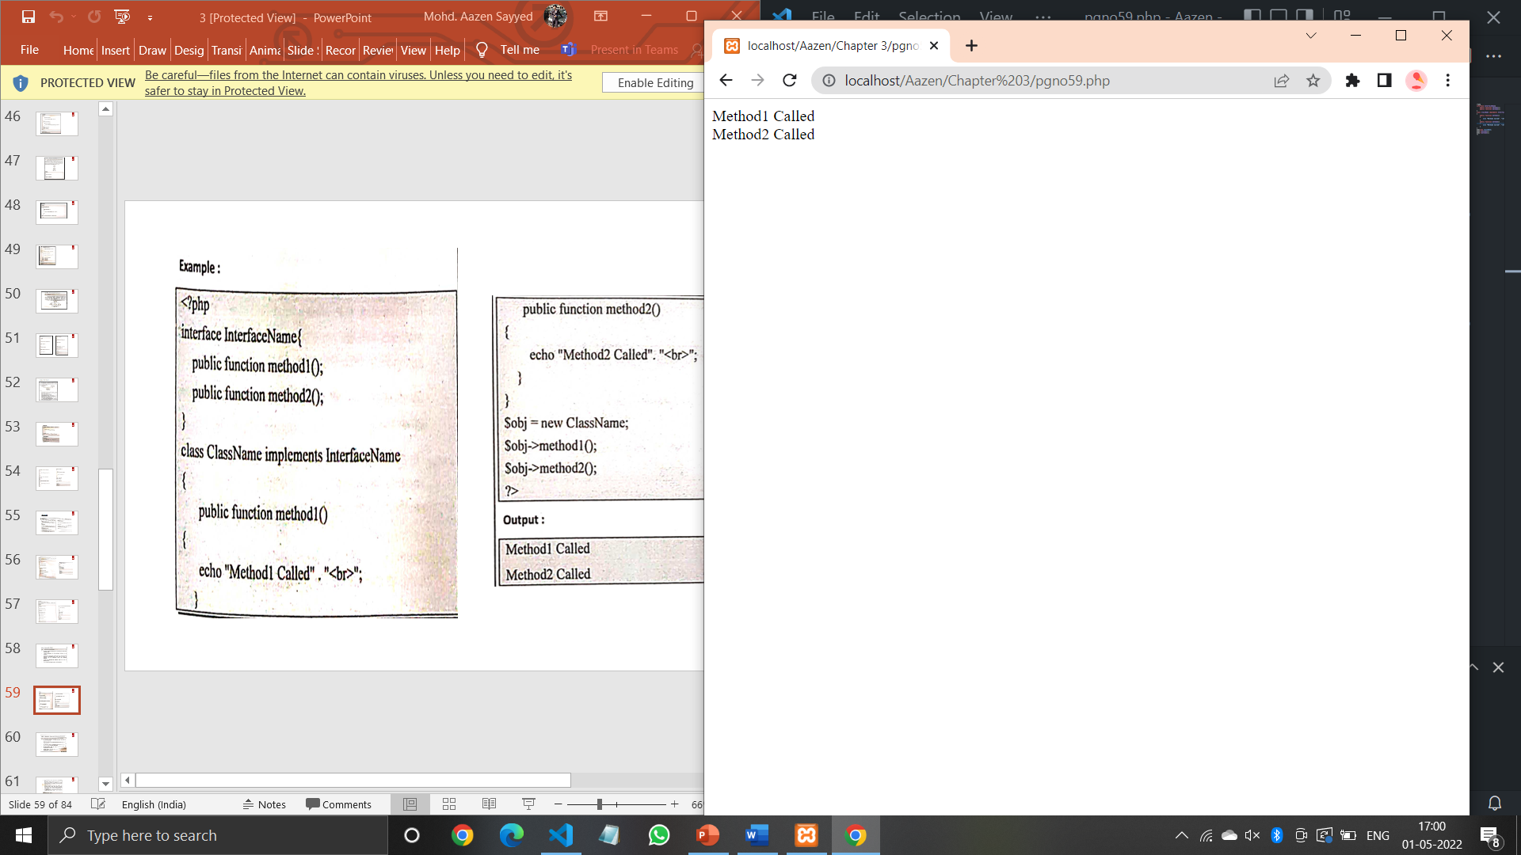

**Code (Pgno. 62):**

<?php

abstract class Base

{

    abstract function printdata();

}

class Derived extends base

{

    function printdata()

    {

        echo "Derived class";

    }

}

$obj=new Derived;

$obj->printdata();

?>

**Output:**

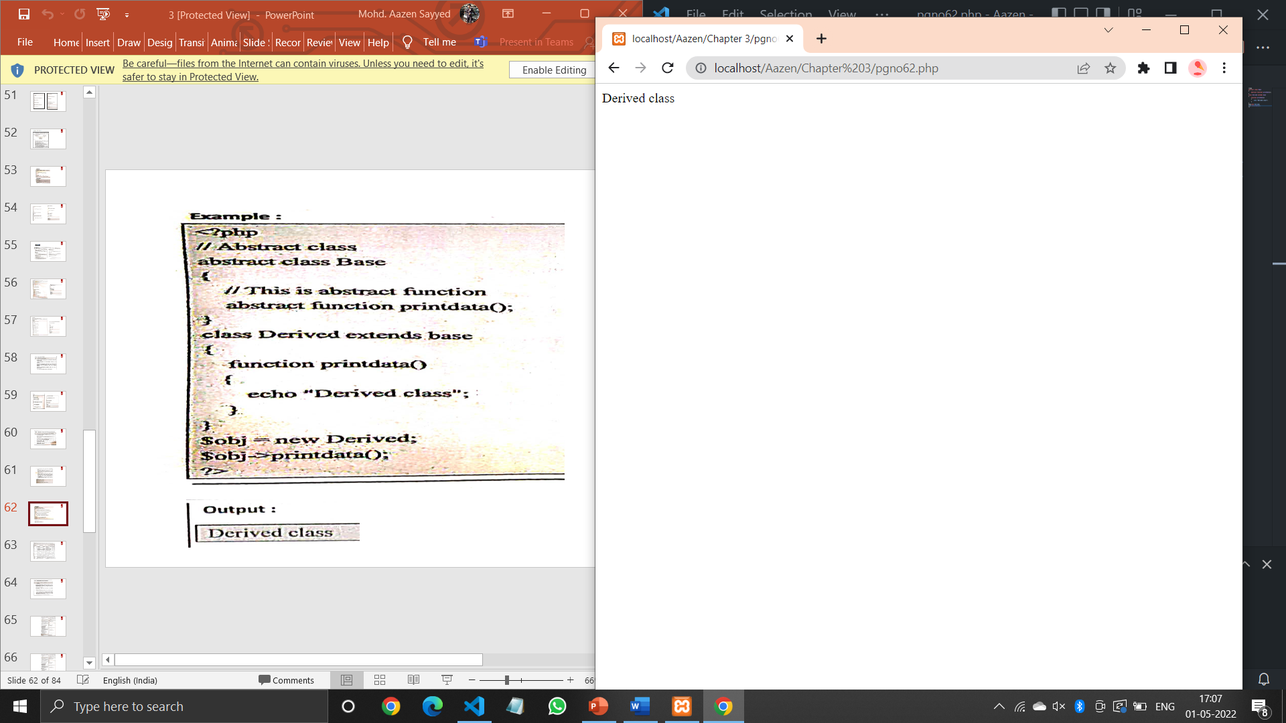

**Code (Pgno. 65):**

<?php

class Toys

{

    private $str;

    public function __set($name,$value)

    {

        $this->str[$name]=$value;

    }

    public function __get($name)

    {

        echo "Overloaded Property name=". $this->str[$name]."<br>";

    }

    public function __isset($name)

    {

        if(isset($this->str[$name]))

        {

            echo "Property \$$name is set<br>";

        }

        else{

            echo "Property\$$name is not set<br>";

        }

    }

    public function __unset($name)

    {

        unset($this->str[$name]);

        echo "\$$name is unset<br>";

    }

}

$objToys = new Toys();

$objToys->overloaded_property="CAR";

echo $objToys->overloaded_property."\n\n";

isset($objToys->overloaded_property);

unset($objToys->overloaded_property);

isset($objToys->overloaded_property);

?>

**Output:**

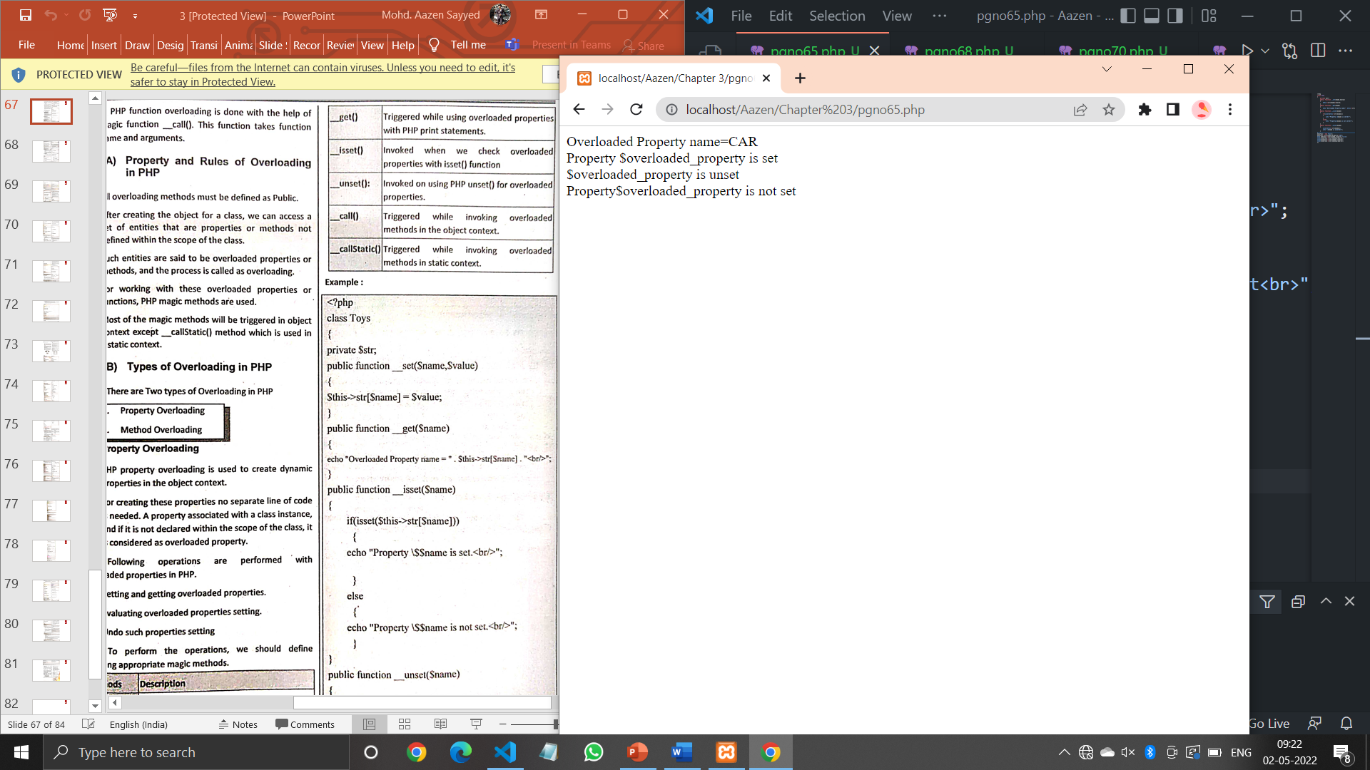

**Code (Pgno. 68):**

<?php

class text

{

    public function display($parameter1)

    {

        echo "Hello world!!!";

    }

    public function display($parameter1,$parameter2)

    {

        echo "Hello India!!!";

    }

}

$obj = new text;

$obj->display('Hello');

?>

**Output:**

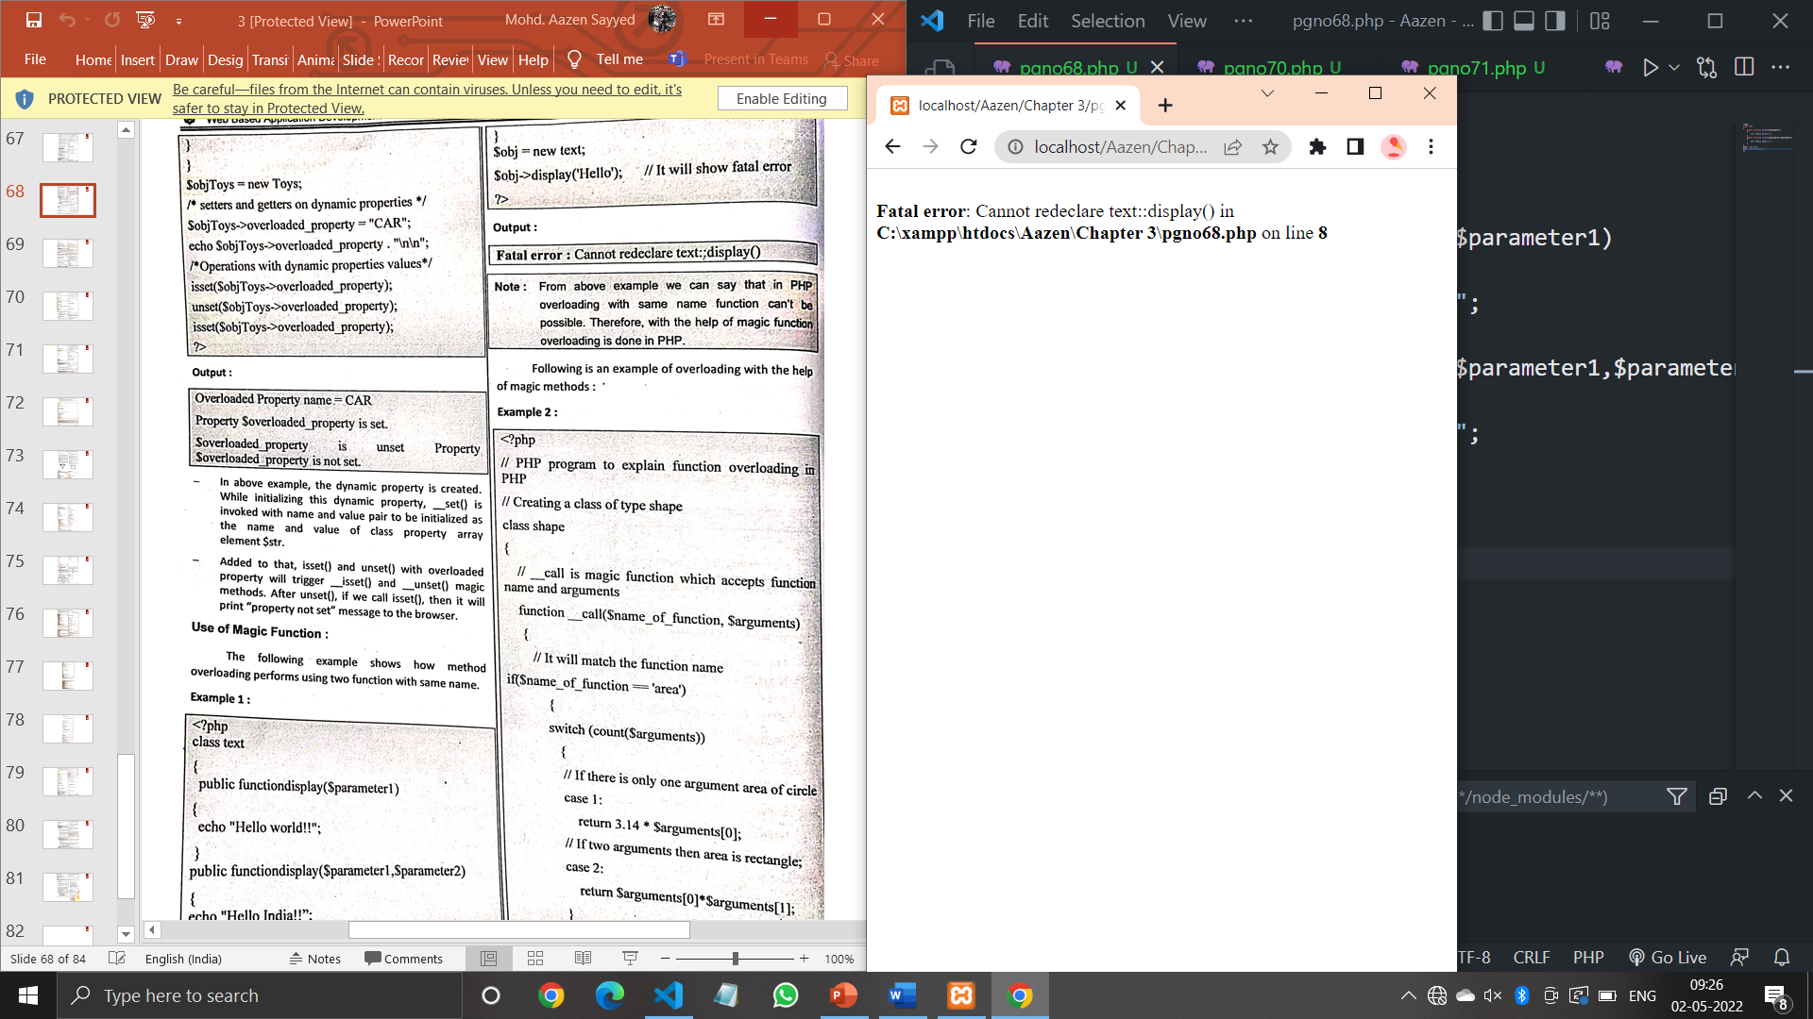

**Code (Pgno. 68):**

<?php

class shape

{

 function __call($name_of_function, $arguments)

 {

if($name_of_function == 'area')

 {

 switch (count($arguments))

 {

 case 1:

 return 3.14 * $arguments[0];

 case 2:

 return $arguments[0]*$arguments[1];

 }

 }

 }

}

$s = new Shape();

echo("Area of circle:" . $s->area(4));

echo "<br>";

echo ("Area of Rectangle:" . $s->area(5, 2)) . "<br>";

?>

**Output:**

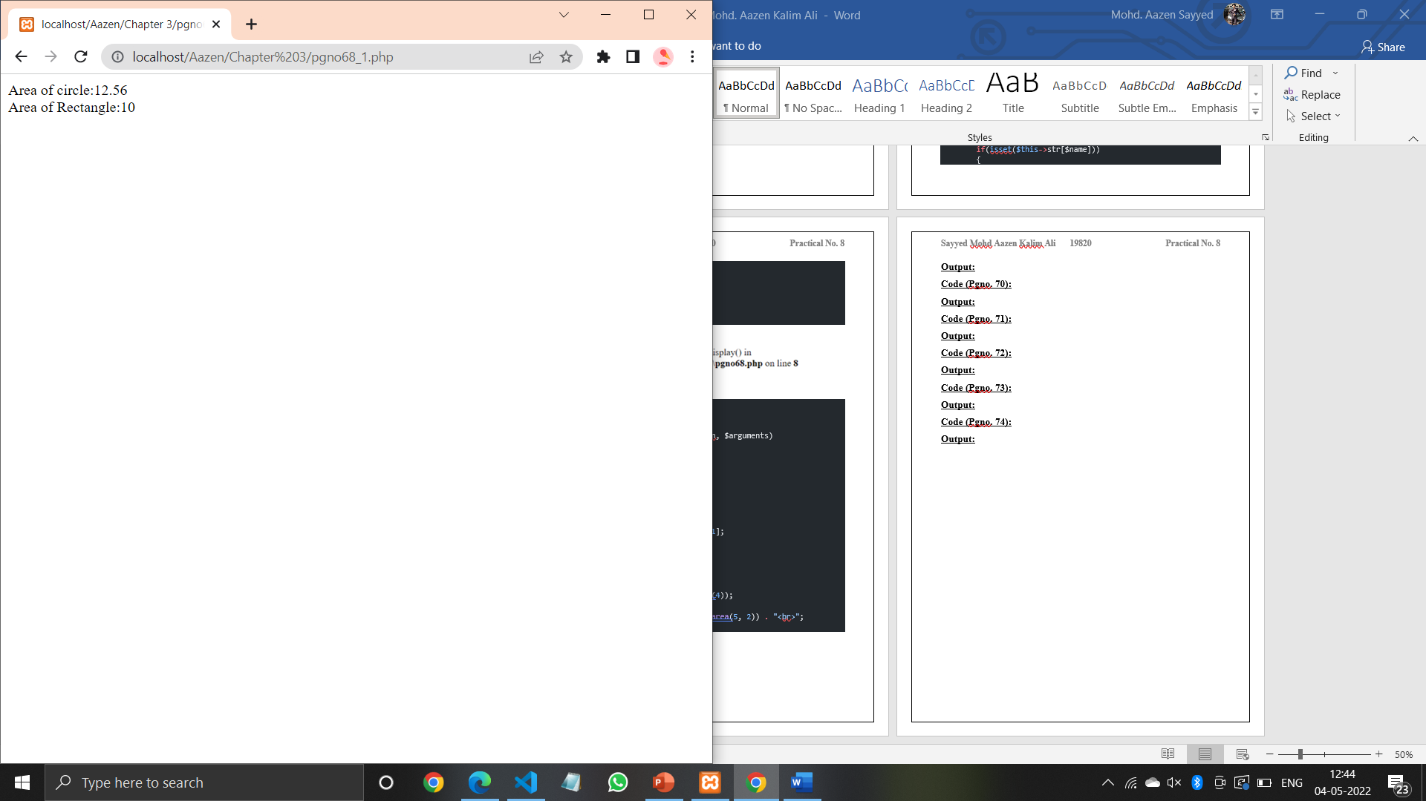

**Code (Pgno. 69):**

<?php

class Shape

{

 public $length;

 public $width;

 public function __construct($length, $width) {

 $this->length = $length;

 $this->width = $width;

 }

 public function intro()

 {

 echo "The length is {$this->length} and the width is {$this->width}.";

 }

}

class square extends Shape

{

 public $height;

 public function __construct($length, $width, $height)

 {

 $this->length = $length;

 $this->width = $width;

 $this->height = $height;

 }

 public function intro() {

 echo "The length is {$this->length}, the width is {$this->width}, the height is {$this->height} ";

 }

}

$s = new square(10,30,50);

$s->intro();

?>

**Output:**

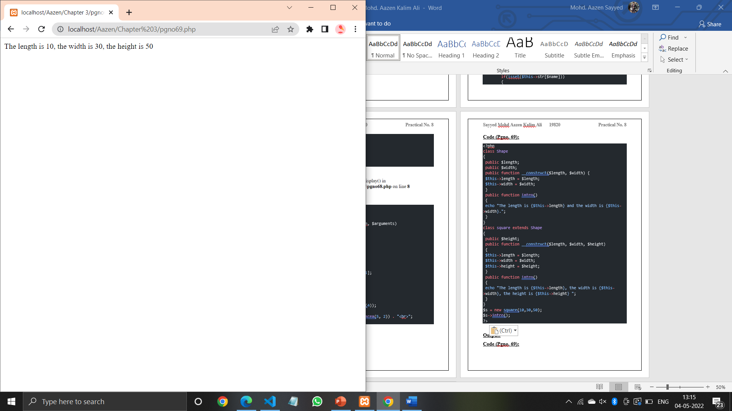

**Code (Pgno. 69):**

<?php

class addition

{

 // __call is magic function which accepts function name and arguments

 function __call($name_of_function, $arguments)

 {

 // It will match the function name

if($name_of_function == 'add')

 {

 switch (count($arguments))

 {

 // If there is only one argument area of circle

 case 1:

 return $arguments[0];

 // IF two arguments then area is rectangle;

 case 2:

 return $arguments[0] + $arguments[1];

 case 3:

 return $arguments[0] + $arguments[1] + $arguments[2];

 }

 }

 }

}

// Declaring a addition type object

$s = new addition;

echo("Return One value:" . $s->add(10))."<br>";

echo ("Addition of two numbers:" . $s->add(10,20)) . "<br>";

echo ("Addition of three numbers:" . $s->add(10,20,30)) . "<br>";

?>

**Output:**

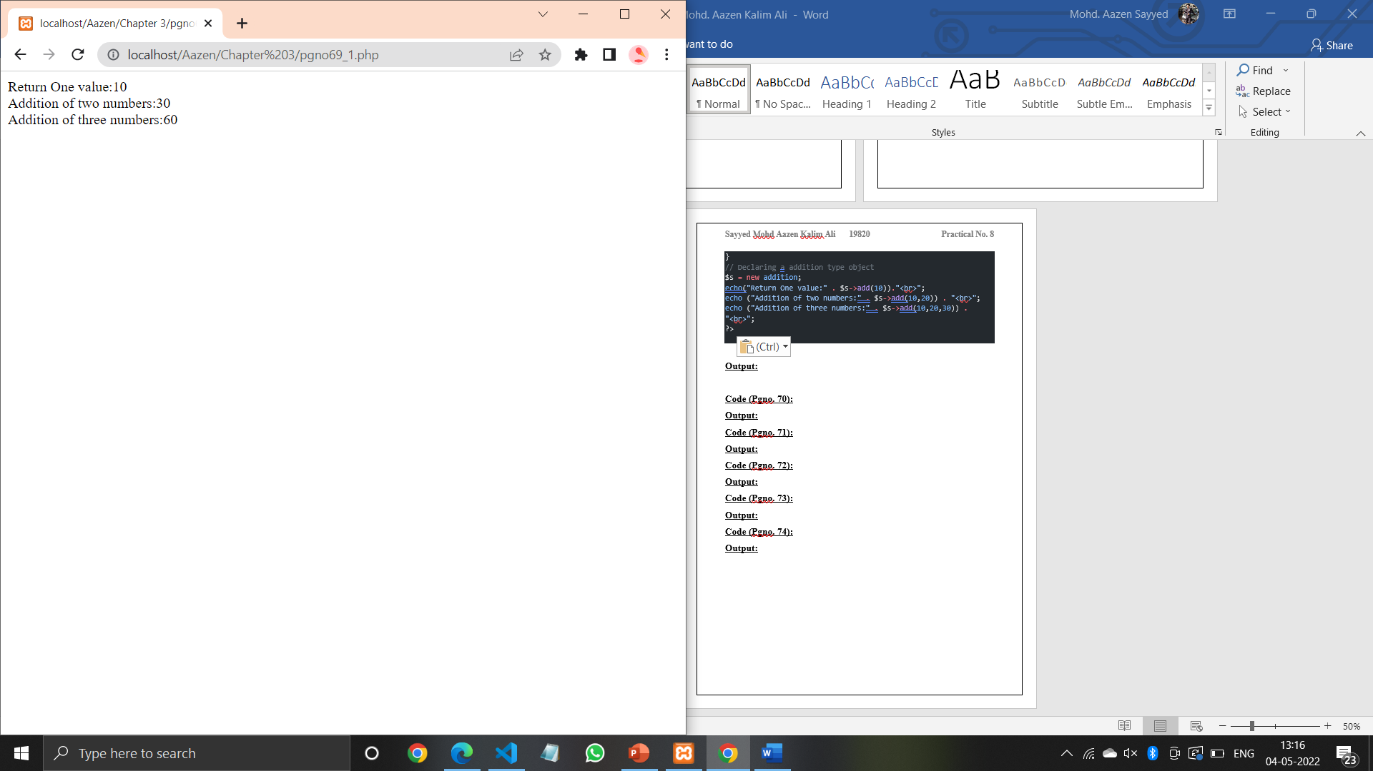

**Code (Pgno. 70):**

<?php

final class A

{

public function disp()

{

echo "Inside the Parent class";

}

}

class B extends A

{

    function disp()

    {

    echo "Inside the Child class";

    }

    }

    $obj=new B();

    $obj->disp();

?>

**Output:**

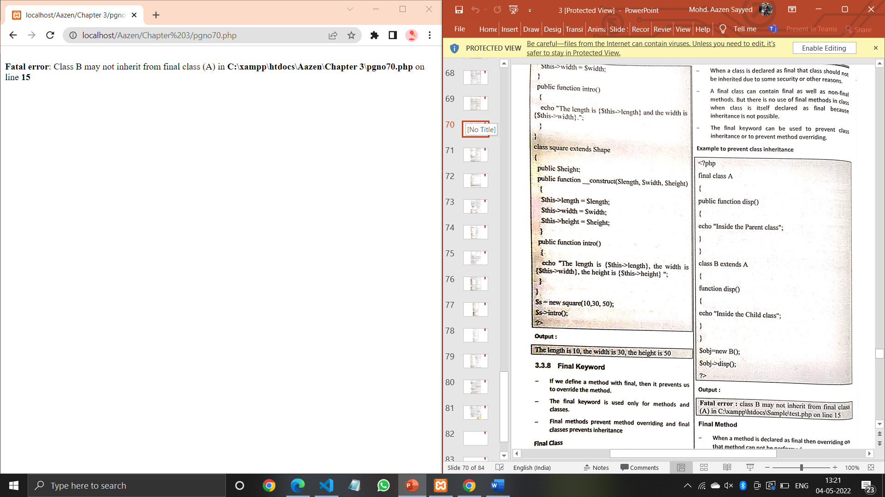

**Code (Pgno. 71):**

<?php

class A

{

final public function disp()

{

echo "Inside the Parent Class";

}

}

class B extends A

{

function disp()

{

echo "Inside the Child Class";

}

}

$obj=new B();

$obj->disp();

?>

**Output:**

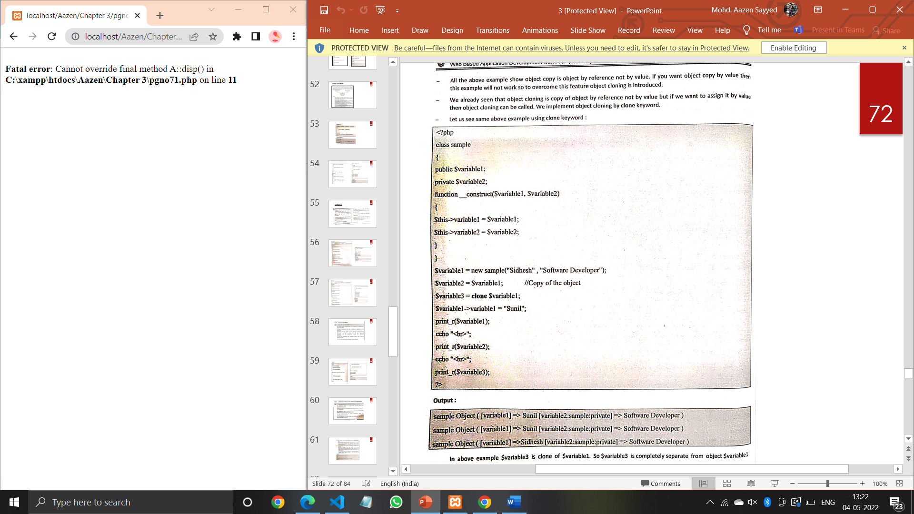

**Code (Pgno. 71):**

<?php

class sample

{

public $variable1;

private $variable2;

function __construct($variable1, $variable2)

{

$this->variable1 = $variable1;

$this->variable2 = $variable2;

}

}

$variable1 = new sample("Siddheh" , "Software Developer");

$variable2 = $variable1; //Copy of the object

$variable1->variable1 = "Sunil";

print_r($variable1);

echo "<br>";

print_r($variable2);

?>

**Output:**

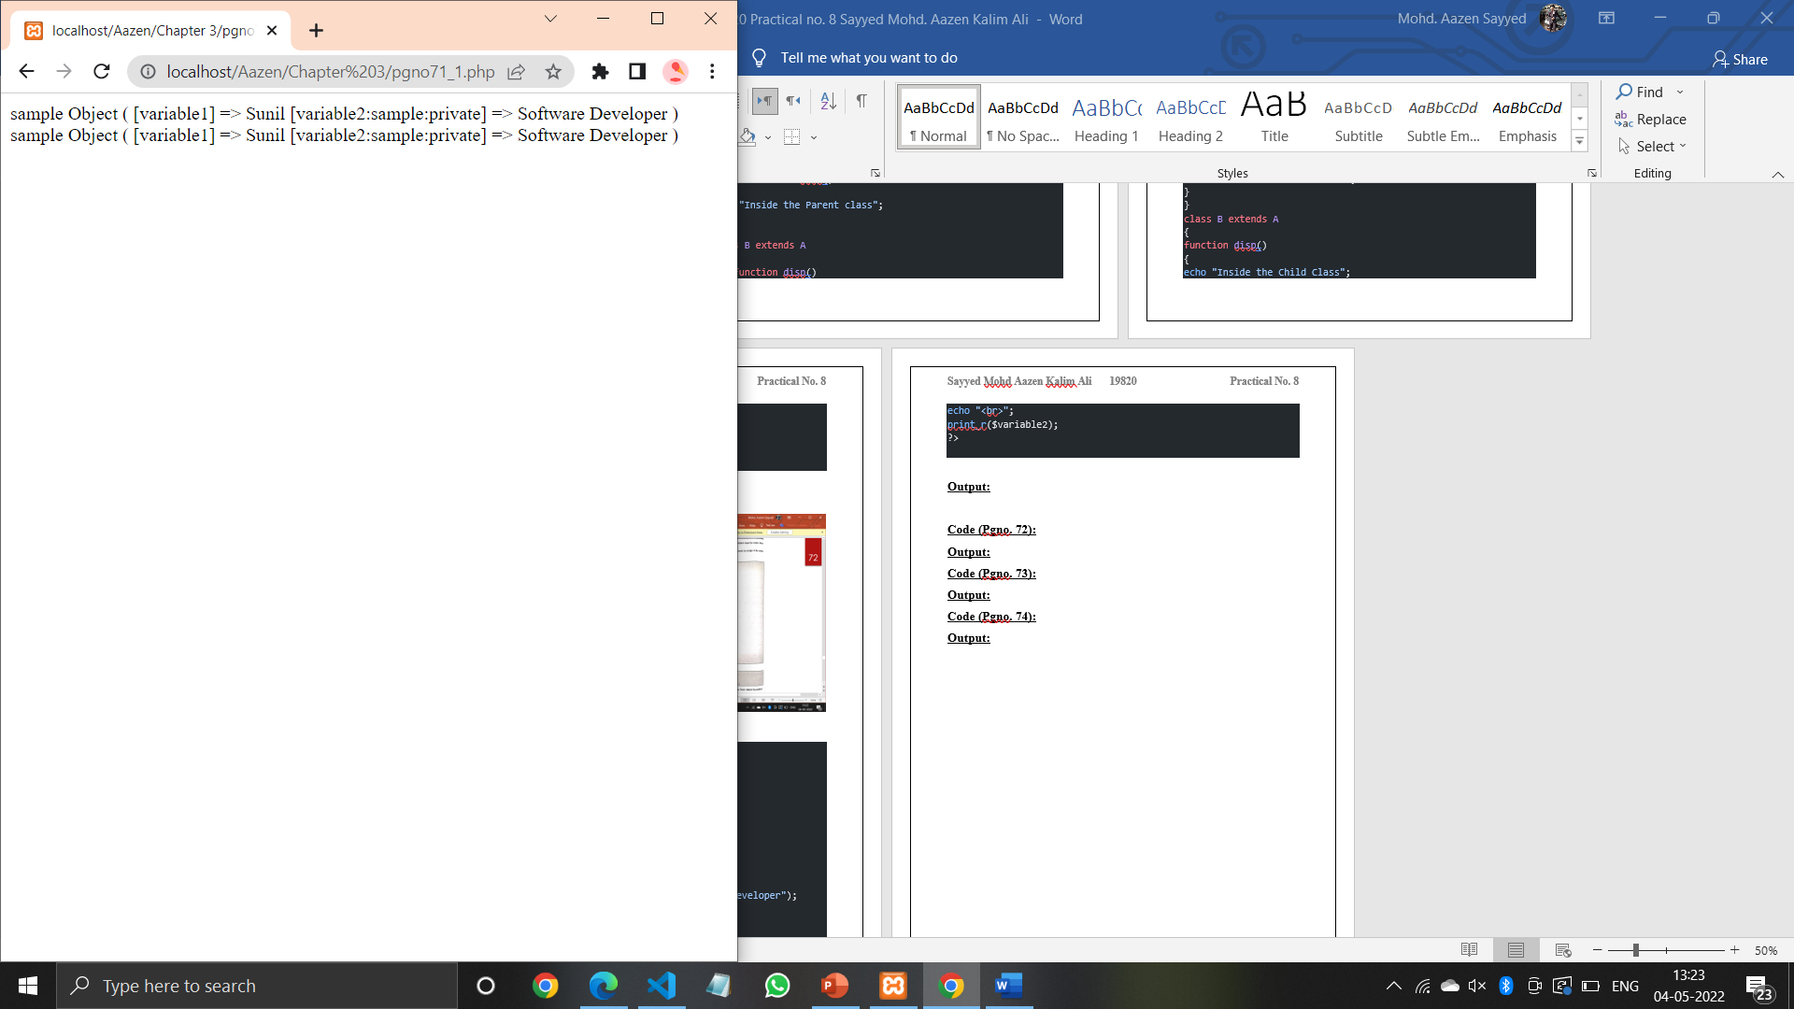

**Code (Pgno. 72):**

<?php

class sample

{

public $variable1;

private $variable2;

function __construct($variable1, $variable2)

{

$this->variable1 = $variable1;

$this->variable2 = $variable2;

}

}

$variable1 = new sample("Sidhesh" , "Software Developer");

$variable2 = $variable1; //Copy of the object

$variable3 = clone $variable1;

$variable1->variable1 = "Sunil";

print_r($variable1);

echo "<br>";

print_r($variable2);

echo "<br>";

print_r($variable3);

?>

**Output:**

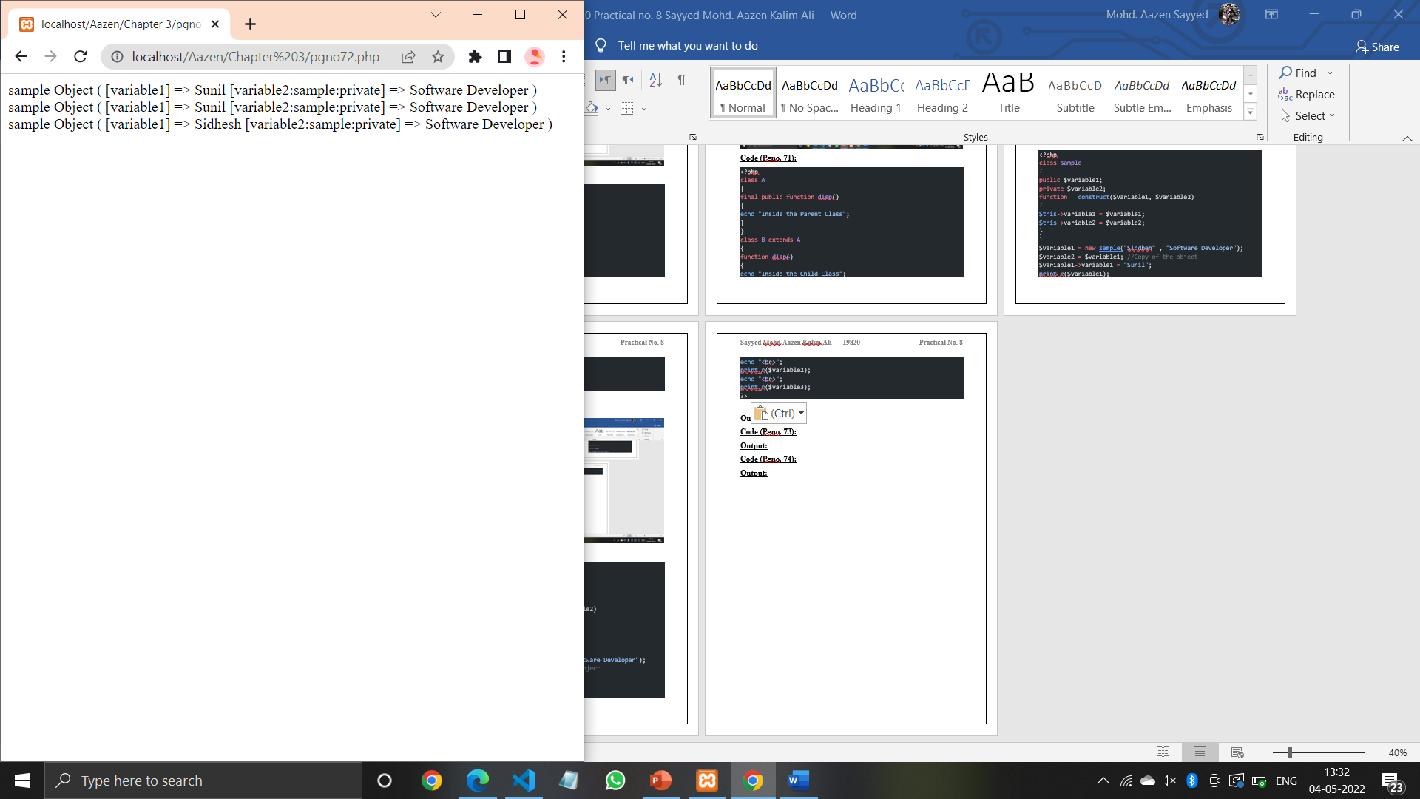

**Code (Pgno. 73):**

<html>

    <head><title></title></head>

<body>

Example of Shallow Copy

    <?php

class Obj

{

 public $id;

 public $size;

 public $color;

 function __construct($id, $size, $color)

 {

    $this->id = $id;

    $this->size = $size;

    $this->color = $color;

    }

    function __clone()

    {

    $green = $this->color->green;

    $blue = $this->color->blue;

    $red = $this->color->red;

    $this->color = new Color($green, $blue,

   $red);

    }

   }

   class Color

   {

    public $green;

    public $blue;

    public $red;

    function __construct($green, $blue, $red)

    {

    $this->green = $green;

    $this->blue = $blue;

    $this->red = $red;

    }

   }

   $color = new Color(23, 42, 223);

   $obj1 = new Obj(23, "small", $color);

   $obj2 = clone $obj1;

   $obj2->id++;

   $obj2->color->red = 255;

   $obj2->size = "big";

   echo "<pre>";print_r($obj1);

   echo "<pre>";print_r($obj2);

?>

</body>

</html>

**Output:**

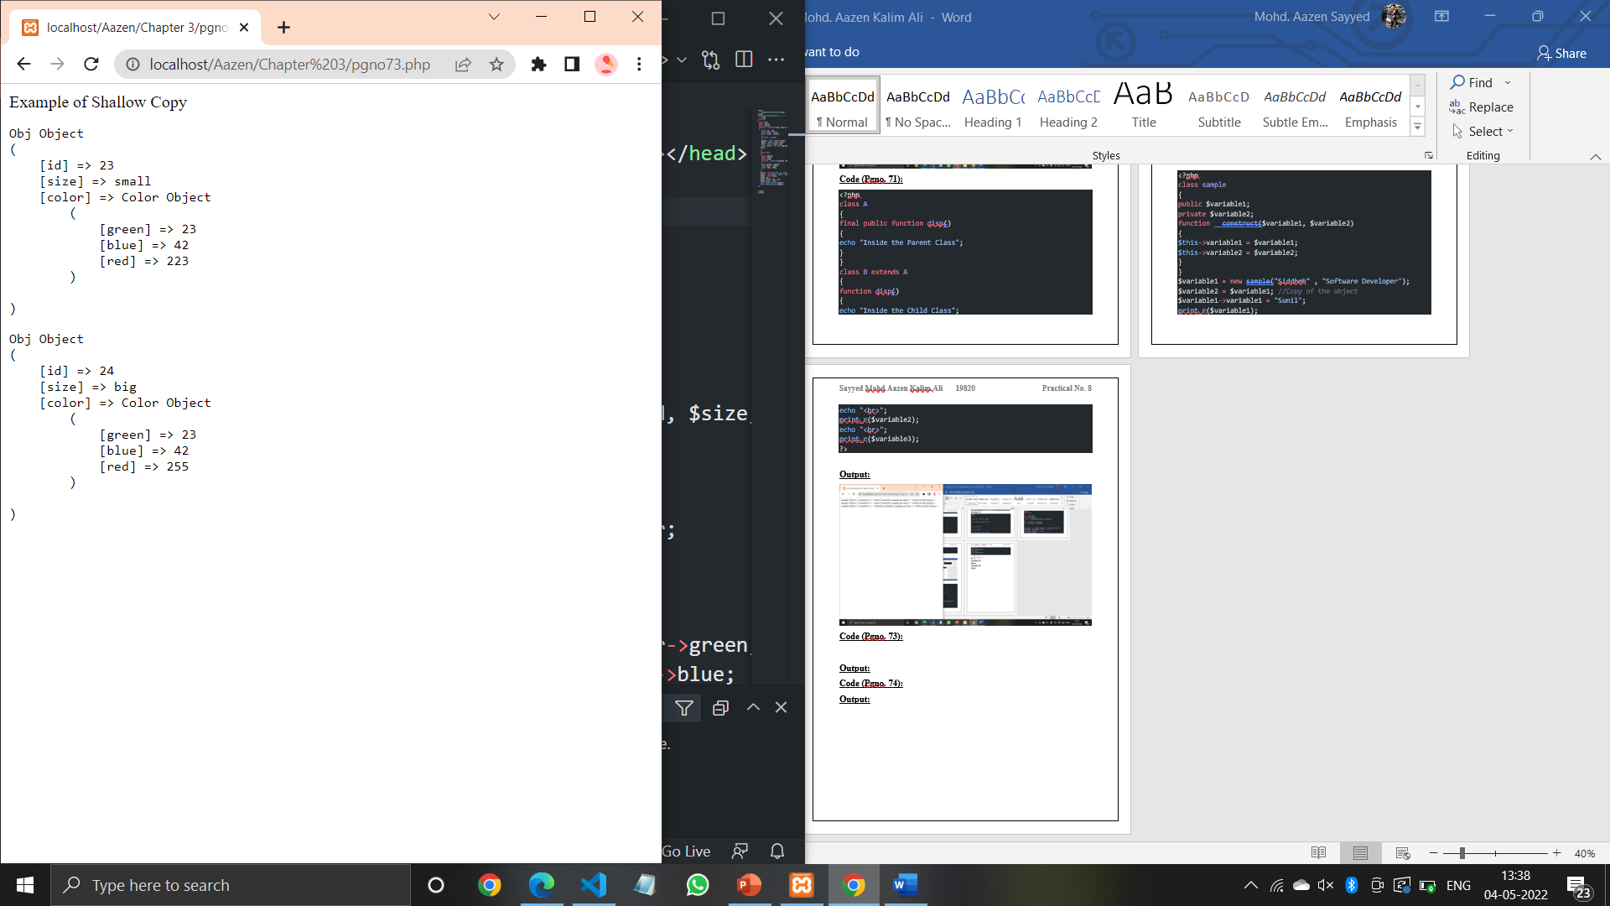

**Code (Pgno. 74):**

<html>

    <head><title></title></head>

<body>

    Example of Deep Copy

<?php

class Obj

{

 public $id;

 public $size;

 public $color;

 function __construct($id, $size, $color)

 {

    $this->id = $id;

    $this->size = $size;

    $this->color = $color;

    }

   }

   class Color

   {

    public $green;

    public $blue;

    public $red;

    function __construct($green, $blue, $red)

    {

    $this->green = $green;

    $this->blue = $blue;

    $this->red = $red;

    }

   }

   $color = new Color(23, 42, 223);

   $obj1 = new Obj(23, "small", $color);

   $obj2 = clone $obj1;

   $obj2->id++;

   $obj2->color->red = 255;

   $obj2->size = "big";

   echo "<pre>";print_r($obj1);

   echo "<pre>";print_r($obj2);

   ?>

</body>

   </html>

**Output:**

